SIMATS ENGINEERING
Department of Information Technology ITA05 – Computer Vision
ASSIGNMENT 1 – CO1

Assignment Title: Apply, Compare and Justify Image Acquisition, Formation and Processing Techniques for a Textile Fabric Defect Inspection System
CO1: Apply the fundamental concepts, image formation models, and processing techniques for analyzing Computer Vision systems.

Student Name | N. BHAVYA SHREE | Register Number | 192572039
Department / Section | Information Technology | Academic Year / Semester | 2025–2026 /  3rd
Faculty Name | Dr. MURALI P | Nature of Assignment | Individual
Duration | 1 Week | Total Marks | 50
Date of Submission | 30.10.2026 | Date of Evaluation | 07.11.2026

Industrial Scenario
Sri Lakshmi Textile Industries, Tiruppur, plans to develop a computer vision-based inspection system for its fabric production line. The system must inspect moving cotton and cotton-polyester fabric,
measure fabric width, and identify holes, broken threads, oil stains, weaving irregularities and colour variations. It must estimate the location of each defect and trigger a marking mechanism so that the defective portion can be identified for rework or rejection.

Given Industrial Data and Constraints
Parameter | Specification
Fabric width | 1,000 mm
Camera field of view | 1,200 × 400 mm
Conveyor speed | 0.6 m/s
Smallest defect to be detected | 1.5 mm
Oil-stain contrast | 5–8 grey levels
Required fabric-width measurement accuracy | ±2 mm
Maximum decision time | 0.5 s

Distance between camera and marking mechanism | 0.3 m
Lighting variation | 500–3,000 lux
Camera mounting height | 700 mm above the fabric
Available computing system | 4-core CPU, 16 GB RAM, no GPU
Software environment | Python, OpenCV and NumPy
Network interface | Gigabit Ethernet
Storage capacity | 2 TB
Maximum project budget | ₹1,50,000
Image retention period | 7 days
Maximum acceptable missed-defect rate | 2%

General Instructions
- Answer all ten tasks.
- For every task, three candidate techniques or approaches are provided. Analyse all three alternatives, compare their suitability for the given industrial scenario, select the most appropriate option and justify your selection.
- Support your answers with calculations, diagrams, tables, observations, screenshots or experimental results wherever applicable.
- Clearly state assumptions and show the steps used in numerical calculations.
- Your justification must consider the given operating conditions, accuracy, processing time, hardware limitations and budget.
- Do not provide only definitions. Relate every answer to the textile fabric inspection application.
- Where implementation is required, use Python, OpenCV and NumPy. Include relevant code snippets and sample output.

1.1 Introduction to Computer Vision

Computer Vision is a branch of computer science and artificial intelligence that enables computers to obtain meaningful information from digital images and videos. It allows a computer system to observe objects, identify important visual characteristics, measure dimensions, recognise patterns and make decisions based on the information obtained from images.

Human beings naturally use their eyes and brains to understand the surrounding environment. For example, a person working in a textile factory can observe a piece of fabric and identify holes, stains, broken threads, colour differences and weaving irregularities. However, manual observation becomes difficult when the production line operates continuously at high speed. Workers may become tired, lighting conditions may change, and different workers may make different decisions about the same defect.

Computer Vision attempts to perform these inspection activities using cameras, image-processing algorithms and computer systems. A camera captures the fabric as a digital image. The computer then processes the image to identify defects and determine their locations. The final output may be displayed to an operator or communicated to a marking mechanism.

In industrial applications, Computer Vision is commonly used for quality inspection, measurement, object detection, surface analysis, identification and process monitoring. It is particularly useful when products move continuously through a production line and require consistent inspection.

1.2 Computer Vision in the Textile Industry

The textile industry involves several production stages, including spinning, weaving, knitting, dyeing, finishing and fabric inspection. During these processes, defects may develop because of machine problems, damaged yarn, incorrect tension, contamination, uneven dyeing or variations in manufacturing conditions.

Fabric inspection is an important quality-control activity because defective material may cause customer complaints, product rejection, financial loss and additional rework. Traditionally, fabric is inspected by workers who observe the material while it moves over an inspection table. Although this method is simple, it has limitations when the fabric moves continuously or when defects are very small.

A Computer Vision-based inspection system can improve this process by capturing images and examining the fabric automatically. The system can identify visible defects, measure the fabric width, record the position of defects and provide information for corrective action.

The proposed system for Sri Lakshmi Textile Industries is intended to inspect moving cotton and cotton-polyester fabric. It must identify the following defects:

Holes: Openings or missing portions in the fabric caused by broken or missing yarn.

Broken threads: Discontinuities in warp or weft threads that affect the structure of the fabric.

Oil stains: Dark or discoloured regions produced by oil or machine contamination.

Weaving irregularities: Unusual patterns caused by incorrect interlacing, uneven thread spacing or weaving faults.

Colour variations: Differences in colour or brightness between neighbouring fabric regions.

The system must also measure the fabric width and determine the location of each detected defect. This information is used to activate a marking mechanism so that the defective portion can be located for rework or rejection.

1.3 Industrial Scenario and Operating Conditions

The assignment specifies the following operating conditions for the textile inspection system. These values form the basis for comparing the different Computer Vision techniques throughout the report.

CV assignment 1 slot D.docx.pdf
Parameter | Given specification
Fabric width | 1,000 mm
Camera field of view | 1,200 × 400 mm
Conveyor speed | 0.6 m/s
Smallest defect to be detected | 1.5 mm
Oil-stain contrast | 5–8 grey levels
Required width accuracy | ±2 mm
Maximum decision time | 0.5 seconds
Camera-to-marker distance | 0.3 m
Lighting variation | 500–3,000 lux
Camera mounting height | 700 mm
Computing system | 4-core CPU, 16 GB RAM, no GPU
Software | Python, OpenCV and NumPy
Network interface | Gigabit Ethernet
Storage capacity | 2 TB
Maximum budget | ₹1,50,000
Image retention period | 7 days
Maximum acceptable missed-defect rate | 2%

These conditions create several technical challenges. The system must detect small defects without losing important image details. It must also operate quickly enough to inspect moving fabric, maintain measurement accuracy and work within the available computer hardware and project budget.

For example, the smallest defect is only 1.5 mm. Therefore, the camera must provide sufficient spatial resolution to represent the defect with enough pixels. Similarly, oil stains may differ from the surrounding fabric by only 5–8 grey levels. This requires suitable lighting and sufficient intensity resolution.

The system must also make its decision within 0.5 seconds. A method that produces highly detailed results but requires several seconds to process every image may not be suitable for the production line.

1.4 Aim of the Proposed System

The aim of the proposed system is to design a Computer Vision-based fabric inspection arrangement that can automatically examine moving fabric, identify common surface defects, measure fabric width and communicate defect positions to a marking mechanism.

1.5 Objectives

The main objectives are:

To study the basic concepts and features of Computer Vision.

To compare manual, image-processing-assisted and automated inspection approaches.

To design a suitable Computer Vision processing pipeline.

To analyse RGB, HSV and grayscale image representations.

To study pixel connectivity methods for identifying defect regions.

To compare rolling-shutter, global-shutter and line-scan cameras.

To calculate suitable image resolutions for detecting small fabric defects.

To analyse the effect of image quantization on low-contrast oil stains.

To study image formation, camera calibration and illumination.

To propose an implementation that considers the given cost, hardware, storage and timing limitations.

To examine how the system must be adapted when the production requirements change.

1.6 Scope of the Proposed System

The proposed system focuses on visual inspection of moving fabric. It includes image acquisition, preprocessing, feature extraction, defect detection, width measurement, defect localisation and communication with the marking mechanism.

The system is intended to use Python, OpenCV and NumPy on a four-core CPU without a GPU. Therefore, the initial design gives importance to efficient image-processing operations that can be executed using available hardware.

The proposed system does not assume that every type of fabric defect can be detected perfectly under all conditions. Detection performance depends on camera resolution, lighting, fabric texture, defect appearance, calibration and the quality of the detection algorithm. Actual performance must be verified using representative fabric samples and independently labelled test images.

TASK 1: OVERVIEW AND FEATURES OF COMPUTER VISION – COMPARISON OF INSPECTION APPROACHES

2. Introduction to Fabric Inspection Approaches

Fabric inspection is the process of examining textile material to identify defects and determine whether the fabric satisfies the required quality standards. Inspection can be performed manually, with computer assistance or through a fully automated Computer Vision system.

The three approaches considered in this task are:

Manual inspection by trained workers.

Image-processing-assisted inspection.

Fully automated Computer Vision inspection.

Each approach has a different level of human involvement, automation, processing capability and operating cost. The most suitable approach must be selected by considering the production speed, smallest defect size, required measurement accuracy, decision time and available resources.

2.1 Approach A – Manual Inspection by Trained Workers

2.1.1 Meaning of Manual Inspection

Manual inspection is a traditional quality-control method in which trained workers visually examine fabric to identify defects. The fabric is generally spread over an inspection table or moved along a conveyor under suitable lighting. Workers observe the fabric surface and identify visible abnormalities.

The worker uses visual judgement and experience to distinguish normal fabric texture from defects. If a defect is found, the worker may stop the fabric, mark the defective location or record the defect in an inspection sheet.

Manual inspection does not require a camera-processing system or advanced computer software. It mainly depends on the skill, experience and attention of the inspector.

2.1.2 Working Principle

The working process of manual inspection can be explained through the following stages:

Stage 1 – Fabric movement

The fabric is placed on an inspection table or conveyor. It moves through the inspection area at a controlled speed.

Stage 2 – Visual observation

A trained worker observes the fabric surface under available lighting. The worker examines the material for visible defects such as holes, stains, broken threads and colour variations.

Stage 3 – Defect identification

When an abnormal region is observed, the worker identifies the possible defect type based on its appearance.

Stage 4 – Defect marking

The worker marks the defective region using chalk, stickers or another marking material. The marking indicates the location that requires further inspection or correction.

Stage 5 – Quality decision

The worker decides whether the fabric is acceptable, requires rework or should be rejected according to the quality requirements.

2.1.3 Block Diagram of Manual Inspection

Fabric from production line

Inspection table and lighting

Visual observation by trained worker

Defect identification and judgement

Manual marking and quality decision

Figure 1: Block diagram of manual fabric inspection.



2.1.4 Identification of Different Fabric Defects

Manual inspectors use the visible appearance of fabric to identify different types of defects.

A. Hole detection

A hole appears as an opening or missing material region. The inspector looks for an unusual gap in the normal fabric structure. Small holes may be difficult to observe when the fabric has a complex texture or when lighting is poor.

B. Broken-thread detection

Broken threads create discontinuities in the normal yarn pattern. A trained worker observes whether warp or weft threads are missing, interrupted or incorrectly positioned.

C. Oil-stain detection

Oil stains may appear as dark, shiny or discoloured regions. Their visibility depends on the colour of the fabric, the amount of oil and the surrounding lighting. Very faint stains may be difficult to identify because their appearance can be similar to normal variations in fabric texture.

D. Weaving-irregularity detection

Weaving irregularities occur when the normal arrangement of warp and weft threads is disturbed. Workers examine the fabric pattern to identify uneven spacing, missing interlacing or abnormal thread arrangements.

E. Colour-variation detection

Colour variations may appear as patches, bands or gradual changes in fabric shade. The inspector compares neighbouring regions to identify differences in colour.

2.1.5 Advantages of Manual Inspection

Simple implementation: Manual inspection does not require complicated software or computer hardware.

Low initial equipment cost: Existing workers and inspection tables may be sufficient to begin the process.

Human judgement: Experienced workers can use their knowledge to recognise unusual defects that may not have been included in predefined computer rules.

Flexible operation: Workers can change their inspection judgement when the fabric type or quality requirement changes.

Easy interpretation: A worker can directly understand the physical appearance and location of a defect.

2.1.6 Limitations of Manual Inspection

Human fatigue: Continuous observation can reduce concentration and increase the possibility of missing defects.

Inconsistent decisions: Different workers may classify the same defect differently.

Limited speed: A person may not be able to inspect every small defect when the conveyor operates continuously.

Measurement limitations: Estimating the exact size and position of a defect by eye may not provide the required accuracy.

Limited traceability: If inspection results are recorded manually, maintaining a complete image-based record of every defect becomes difficult.

Lighting dependency: Poor or changing lighting can make small defects difficult to identify.

Labour requirement: Continuous production may require several inspectors working in shifts.

2.1.7 Suitability for the Given Textile Scenario

The textile production line operates at 0.6 m/s and must detect defects as small as 1.5 mm. The system must also maintain a width-measurement accuracy of ±2 mm and provide a decision within 0.5 seconds.

Manual inspection may be useful as a supporting quality-control method, but it is not the strongest primary approach for this production requirement. Small defects and low-contrast oil stains may be missed during continuous observation. Manual measurement also makes it difficult to maintain consistent accuracy across the full fabric width.

Therefore, manual inspection alone is not recommended as the main inspection method. It can still be used for periodic verification, reviewing uncertain defects and checking the performance of the automated system.

2.2 Approach B – Image-Processing-Assisted Inspection

2.2.1 Meaning of Image-Processing-Assisted Inspection

Image-processing-assisted inspection combines a camera and image-processing software with human judgement. The camera captures an image of the fabric, and the computer improves or analyses the image before presenting it to an operator.

In this approach, the computer helps the worker observe defects more clearly. It may adjust brightness, improve contrast, remove noise, enlarge selected regions or highlight unusual areas. However, the final quality decision is still made by the human operator.

This method provides more visual information than ordinary manual inspection while retaining human control over the final decision.

2.2.2 Working Principle

The image-processing-assisted inspection process consists of the following stages.

Stage 1 – Image acquisition

A digital camera captures images of the fabric while it moves through the inspection area. The camera converts the light reflected from the fabric into digital pixel values.

Stage 2 – Image preprocessing

The captured image may contain noise, uneven illumination or low contrast. Preprocessing operations are applied to improve image quality.

Common operations include:

Image resizing.

Noise reduction.

Brightness adjustment.

Contrast enhancement.

Colour-space conversion.

Image sharpening.

Stage 3 – Defect highlighting

The software identifies suspicious regions using image-processing operations. For example, thresholding can highlight dark regions that may correspond to oil stains or holes.

Stage 4 – Display to the operator

The processed image is displayed on a computer monitor. Defect candidates may be shown using rectangles, outlines or different colours.

Stage 5 – Human verification

The operator examines the original and processed images and decides whether the highlighted region is a real defect.

Stage 6 – Recording and marking

After confirmation, the defect information can be recorded and communicated to the marking mechanism.

2.2.3 Block Diagram of Image-Processing-Assisted Inspection

Moving fabric

Camera captures fabric image

Image preprocessing and enhancement

Defect candidate highlighting

Operator reviews processed image

Final decision, recording and marking

Figure 2: Block diagram of image-processing-assisted fabric inspection.

2.2.4 Image Enhancement Techniques

Image enhancement improves the visual quality of an image so that important details become easier to observe. It does not necessarily identify the defect by itself. Instead, it prepares the image for further examination.

A. Brightness adjustment

Brightness adjustment changes the overall intensity of an image. If the captured fabric image is too dark, increasing brightness may make the fabric pattern more visible.

However, excessive brightness can remove details in bright regions. Therefore, brightness must be adjusted carefully.

B. Contrast enhancement

Contrast enhancement increases the difference between neighbouring intensity values. It can help make faint stains more visible.

For the given scenario, oil stains have only 5–8 grey levels of contrast. This means the difference between the stain and the surrounding fabric may be small. Contrast enhancement may help an operator observe these regions more clearly.

C. Noise reduction

Noise reduction removes unwanted variations that occur during image acquisition. Gaussian filtering and median filtering are commonly used methods.

Gaussian filtering smooths small intensity variations, while median filtering is useful for removing certain types of impulse noise. Filtering must be selected carefully because excessive smoothing may remove the fine details of broken threads.

D. Thresholding

Thresholding converts an image into a binary representation based on an intensity condition. Pixels satisfying the threshold condition are assigned to one class, while other pixels are assigned to another class.

For example, dark regions may be highlighted as possible oil stains. However, a simple threshold may also detect natural dark variations in fabric texture. Therefore, thresholding alone is not sufficient for reliable inspection.

E. Edge enhancement

Edge enhancement highlights boundaries between regions. It can help reveal holes, discontinuities and unusual thread structures.

2.2.5 Advantages of Image-Processing-Assisted Inspection

Improved visibility: Enhancement operations make faint or small defects easier for operators to observe.

Human verification: The operator can reject false alarms caused by normal fabric texture.

Image storage: Captured images can be stored for later inspection and quality records.

Reduced visual effort: The operator does not need to examine only the raw fabric; suspicious regions can be highlighted automatically.

Flexible judgement: Human knowledge can still be used when a new or unusual defect appears.

Useful for training: Processed images can help workers understand different defect types.

2.2.6 Limitations of Image-Processing-Assisted Inspection

Human decision dependency: The final decision still depends on the operator.

Processing delay: Image capture, enhancement and display require time.

Operator fatigue: The worker may still become tired while reviewing images continuously.

False alarms: Normal fabric patterns may be highlighted as possible defects.

Display dependency: Poor monitor quality or incorrect display settings may affect defect visibility.

Limited automation: The system cannot independently complete the entire inspection and marking process.

Throughput limitation: The operator must review the highlighted regions, which may become difficult when many images are generated.

2.2.7 Suitability for the Given Textile Scenario

Image-processing-assisted inspection is better than ordinary manual inspection when small or low-contrast defects need to be examined. The camera can capture detailed images, and enhancement operations can improve the visibility of faint oil stains and thread irregularities.

However, the system still requires a human operator to make the final decision. Since the fabric moves at 0.6 m/s and the required decision time is 0.5 seconds, continuous manual verification may become a bottleneck.

Therefore, this approach is suitable as a supporting inspection method, especially for uncertain defects and periodic quality audits. It is not the best choice as the only inspection method for the complete production line.

2.3 Approach C – Fully Automated Computer Vision Inspection

2.3.1 Meaning of Automated Computer Vision Inspection

Fully automated Computer Vision inspection uses cameras, image-processing algorithms and decision-making software to inspect fabric without requiring an operator to examine every captured image.

The system captures images, processes the pixel information, extracts useful features, identifies defects, measures their positions and produces a final decision automatically.

The detected defect information can be communicated to a marking mechanism located downstream from the camera. This allows the defective fabric region to be marked as it moves along the conveyor.

Unlike image-processing-assisted inspection, the automated system does not require a human to approve every normal decision. Human operators can still supervise the system, review uncertain cases and perform maintenance.

2.3.2 Working Principle

Stage 1 – Image acquisition

A camera captures the moving fabric under controlled illumination. The captured image is transferred to the processing computer.

Stage 2 – Preprocessing

The image is prepared for analysis. Operations may include noise removal, colour conversion, brightness correction and image normalization.

Stage 3 – Feature extraction

The system extracts useful visual information such as intensity, colour, edges, texture, connected regions and geometric measurements.

Stage 4 – Defect detection

The extracted features are examined to identify possible holes, broken threads, oil stains, weaving irregularities and colour variations.

Stage 5 – Measurement and localisation

The system estimates the size and position of each defect. Camera calibration is used to convert pixel coordinates into physical measurements such as millimetres.

Stage 6 – Decision-making

The system compares the detected defect information with predefined quality rules. It determines whether the fabric region is acceptable, requires marking or should be rejected.

Stage 7 – Marking mechanism control

The defect position is transferred to the marking mechanism. Since the marking mechanism is 0.3 m downstream from the camera, the system must account for fabric movement and communication delay.

Stage 8 – Data storage

The system stores the defect type, position, image and decision for future review and quality analysis.

2.3.3 Block Diagram of Automated Computer Vision Inspection

Moving fabric

Camera and controlled illumination

Image acquisition and preprocessing

Feature extraction and defect detection

Measurement and defect localisation

Automatic quality decision

Defect marking mechanism

Image and result storage

Figure 3: Block diagram of automated Computer Vision inspection.

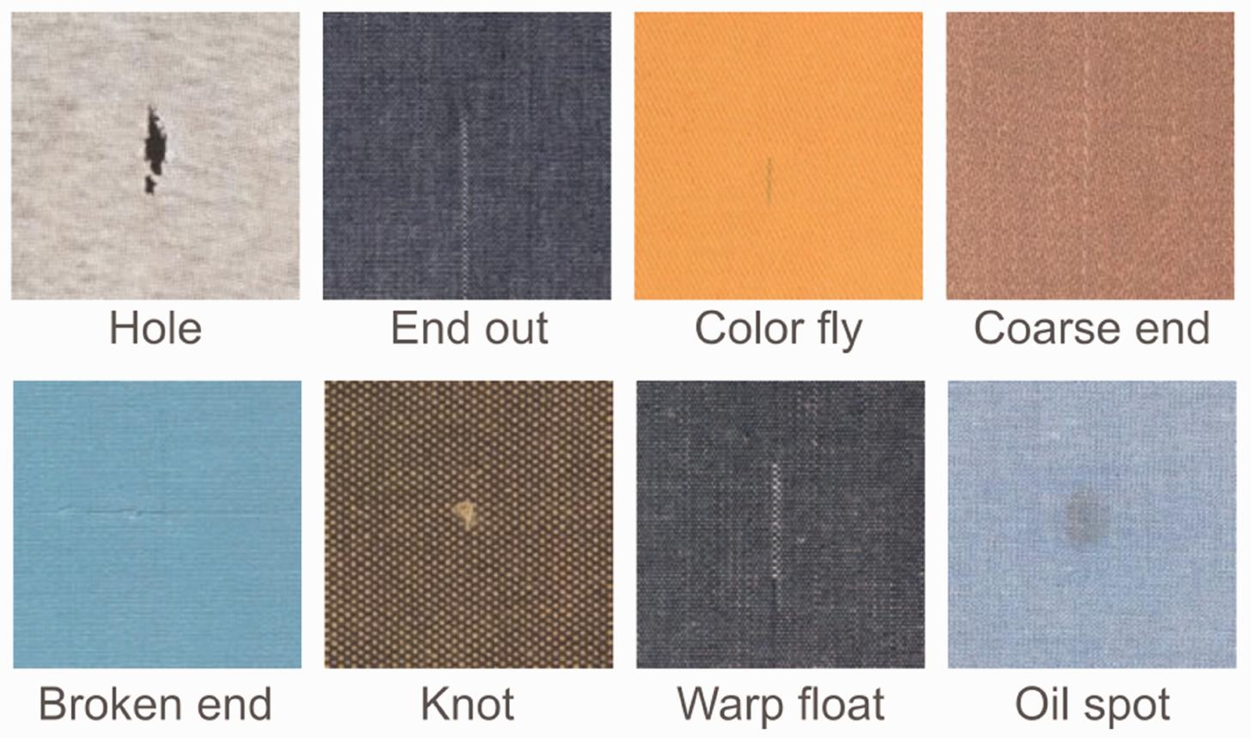

A. Hole detection

A hole may appear as a region that differs significantly from the surrounding fabric texture. The system can use intensity differences, local texture information and connected-component analysis to identify candidate holes.

The detected region is measured by calculating its pixel area and boundary. After calibration, the pixel measurements can be converted into physical dimensions.

B. Broken-thread detection

Broken threads produce unusual lines, gaps or interruptions in the normal fabric pattern. Edge detection and texture analysis can be used to identify these irregularities.

The system may compare the local thread direction with the expected pattern. A discontinuity or unexpected gap can be marked as a possible broken thread.

C. Oil-stain detection

Oil stains may produce changes in brightness, colour and texture. The system can analyse grayscale intensity and HSV colour information to identify suspicious regions.

Since the given oil-stain contrast is only 5–8 grey levels, the image acquisition system must maintain stable lighting and sufficient intensity resolution. A simple fixed threshold may not be reliable under changing illumination.

D. Weaving-irregularity detection

The normal fabric contains repeated patterns formed by warp and weft threads. Weaving irregularities disturb this repeated structure.

The system can analyse local texture, edge orientation and periodic patterns. Regions that differ from the expected pattern can be treated as defect candidates.

E. Colour-variation detection

Colour variations can be detected by comparing the colour values of neighbouring regions. RGB and HSV representations can be used to examine differences in colour and brightness.

The system should consider normal fabric shade variations so that acceptable variations are not incorrectly classified as defects.

2.3.5 Advantages of Automated Computer Vision Inspection

High consistency: The same processing rules are applied to every image.

Continuous operation: The system can inspect fabric continuously without depending on human visual attention for every decision.

Fast processing potential: Suitable algorithms can process images automatically within the required decision time, subject to actual benchmarking.

Accurate measurement potential: Calibration allows pixel measurements to be converted into physical dimensions.

Traceability: Images, defect positions and inspection decisions can be stored.

Reduced repetitive labour: Workers can focus on supervision, maintenance and exceptional cases.

Automatic marking: Defect locations can be sent to the downstream marking mechanism.

Repeatability: Identical input images processed with the same software settings should produce consistent results.

2.3.6 Limitations of Automated Computer Vision Inspection

Initial investment: Cameras, lenses, lighting, computer hardware and installation require investment.

Lighting sensitivity: Changes in illumination may affect the appearance of defects.

Algorithm dependency: The system may fail to detect defects that are not properly represented in its rules or training data.

Calibration requirement: Accurate physical measurement requires correct camera calibration.

Maintenance: Cameras, lighting and mechanical components must be inspected and maintained.

False detections: Normal fabric texture may be incorrectly identified as a defect.

Hardware limitations: High-resolution images may require considerable memory and processing time.

New defect adaptation: New defect types may require additional rules, data collection or model training.

2.3.7 Suitability for the Given Textile Scenario

Automated Computer Vision is the most suitable primary approach for the textile inspection system because it can combine image acquisition, defect detection, measurement, localisation and marking into one workflow.

The production line requires continuous inspection at 0.6 m/s. The smallest defect is 1.5 mm, and the decision must be generated within 0.5 seconds. An automated system can be designed around these requirements using a suitable camera, controlled lighting and efficient CPU-based image-processing algorithms.

However, selecting an automated system does not automatically guarantee that the missed-defect rate will be below 2%. This requirement must be verified using a labelled dataset containing representative examples of all relevant defect types. The system should also be tested under different fabric textures and lighting conditions.

For the available four-core CPU without a GPU, a carefully designed classical image-processing pipeline is a practical starting point. More computationally demanding deep-learning methods should be considered only after checking their hardware requirements and measured processing time.

2.4 Comparison of the Three Inspection Approaches
Feature | Manual inspection | Image-processing-assisted | Automated Computer Vision
Main decision-maker | Human worker | Human operator | Computer system
Camera requirement | Not essential | Required | Required
Image enhancement | Human observation | Software enhancement | Software preprocessing
Defect identification | Visual judgement | Software highlights, human confirms | Algorithmic detection
Consistency | Depends on worker | Depends partly on operator | Consistent rules
Continuous operation | Limited by fatigue | Limited by review workload | Designed for continuous operation
Measurement | Visual estimation | Image-supported estimation | Calibrated pixel measurement
Record keeping | Manual records | Images and operator records | Automatic image and result logging
Initial equipment cost | Low | Medium | Higher
Human involvement | High | Medium to high | Mainly supervision
Suitability for the given line | Limited | Supporting method | Recommended primary method

2.5 Selection of the Most Suitable Approach

After comparing the three approaches, fully automated Computer Vision inspection is recommended as the primary inspection method for Sri Lakshmi Textile Industries.

The selection is based on the following reasons:

Continuous production: The fabric moves at 0.6 m/s. Automated inspection is more suitable for examining images continuously than depending entirely on manual observation.

Small defect detection: The system must detect defects as small as 1.5 mm. Image-based processing provides a measurable way to analyse small regions.

Width measurement: The required accuracy is ±2 mm. Camera calibration and pixel-to-millimetre conversion can support this measurement.

Decision time: The maximum decision time is 0.5 seconds. A lightweight CPU-based pipeline can be designed and benchmarked against this requirement.

Defect localisation: The system must communicate the defect position to a marking mechanism. Automated localisation makes this possible.

Traceability: The requirement to retain images for seven days supports automatic storage of inspection records.

Consistency: Automated rules can be applied repeatedly without the same fatigue-related changes that affect human inspection.

2.5.1 Recommended Hybrid Operation

Although automated Computer Vision is selected as the primary method, the system should retain a human-supervision facility.

The recommended arrangement is:

The automated system inspects every captured fabric image.

Clearly identified defects are recorded and marked automatically.

Uncertain detections are displayed to an operator for review.

Workers periodically examine selected fabric samples.

The system's stored images are used to investigate missed defects and false alarms.

Detection rules are updated after validation when new defect types are identified.

This arrangement combines the speed and repeatability of automated inspection with the flexibility of human judgement.

2.6 Limitations of the Selected Approach and Corrective Measures

Limitation 1 – Lighting variation

The specified illumination varies from 500 to 3,000 lux. Such changes can affect pixel brightness and make a faint oil stain appear different in separate images.

Corrective measure: Use controlled illumination, shield the inspection area from external light where practical, and apply brightness normalization or flat-field correction after image acquisition.

Limitation 2 – Unknown defect types

A rule-based system may not detect a defect that has not been represented in its detection rules.

Corrective measure: Maintain an anomaly-review category, store uncertain images and periodically update the detection system using newly labelled fabric samples.

Limitation 3 – Processing time

High-resolution images may require more memory and processing time than low-resolution images.

Corrective measure: Select an appropriate resolution, process only necessary regions where possible, use efficient OpenCV operations and measure the complete processing time on the actual four-core computer.

Limitation 4 – Calibration errors

Incorrect camera position or calibration may cause errors in fabric-width measurements and defect localisation.

Corrective measure: Calibrate the camera using a known reference pattern, mount it securely and verify the measurement using physical reference measurements.

Limitation 5 – False detections

Normal variations in fabric texture may be incorrectly detected as holes or stains.

Corrective measure: Combine multiple features such as intensity, colour, texture and connected-region size instead of relying on a single threshold.

2.7 Conclusion of Task 1

This task compared manual inspection, image-processing-assisted inspection and fully automated Computer Vision inspection for detecting defects in moving textile fabric.

Manual inspection is simple and flexible but depends heavily on worker attention and experience. Image-processing-assisted inspection improves defect visibility but still requires human verification. Fully automated Computer Vision can perform image acquisition, preprocessing, defect detection, measurement, localisation and marking with consistent processing rules.

Considering the 0.6 m/s conveyor speed, 1.5 mm minimum defect size, ±2 mm width accuracy and 0.5-second decision requirement, automated Computer Vision is recommended as the main inspection approach. Human supervision should remain available for uncertain cases and periodic quality verification.

TASK 2: LEVELS OF COMPUTER VISION – PIPELINE DESIGN AND OPERATION

3. Introduction to Computer Vision Pipelines

A Computer Vision pipeline is a sequence of operations through which an image is converted into useful information and finally into a decision. Each stage performs a particular function, and the output of one stage becomes the input to the next stage.

In a textile inspection system, the pipeline begins with image acquisition. The camera captures the fabric surface, and the processing system examines the image to identify defects. The final output includes the defect category, defect location and quality decision.

The assignment provides three possible pipeline designs:

Low-level pipeline.

Three-level pipeline.

Deep-learning-based pipeline.

These approaches differ in the amount of image analysis they perform, their computational requirements and their ability to produce meaningful defect information.

3.1 Approach A – Low-Level Computer Vision Pipeline

3.1.1 Meaning

A low-level Computer Vision pipeline mainly performs operations directly on image pixels. It focuses on acquiring an image, improving its quality and producing an enhanced image.

At this level, the system does not necessarily understand what the detected regions represent. It performs operations such as filtering, resizing, colour conversion, thresholding and contrast enhancement.

For example, if an oil stain appears as a dark region on the fabric, a low-level operation may increase its contrast. However, the operation alone may not determine whether the dark region is actually an oil stain or simply a normal variation in the fabric.

3.1.2 Working Stages

Stage 1 – Image acquisition

The camera captures the fabric image and converts the reflected light into digital pixel information.

Stage 2 – Image resizing

The image may be resized to a suitable resolution to reduce processing requirements. Resizing should not remove the details needed to detect small defects.

Stage 3 – Noise removal

Noise caused by the camera sensor or surrounding environment is reduced using filtering operations.

Stage 4 – Colour conversion

The original image may be converted from RGB or BGR into grayscale or HSV representation, depending on the required operation.

Stage 5 – Image enhancement

Brightness and contrast are adjusted to improve the visibility of defects.

Stage 6 – Output

The pipeline produces an enhanced image that can be examined by a person or passed to another processing stage.

3.1.3 Block Diagram

Fabric image

Image acquisition

Preprocessing and noise removal

Colour conversion and enhancement

Enhanced image output

Figure 4: Low-level Computer Vision pipeline.

3.1.4 Applications in Textile Inspection

Low-level operations are useful for preparing fabric images before defect analysis.

Gaussian filtering can reduce small image variations.

Median filtering can remove certain isolated noise pixels.

Grayscale conversion can simplify intensity-based analysis.

HSV conversion can separate colour information from brightness.

Contrast enhancement can improve the visibility of faint stains.

Thresholding can produce binary images containing suspicious regions.

For example, a dark oil stain may be easier to observe after contrast enhancement. A hole may appear as a region with an unusual intensity pattern. However, these operations do not independently confirm the defect type.

3.1.5 Advantages

Simple to understand and implement.

Requires comparatively low computational resources.

Useful for image enhancement and preprocessing.

Individual operations can be tested separately.

Suitable for implementation using OpenCV and NumPy.

Can operate on a CPU without requiring a GPU.

3.1.6 Limitations

Does not provide complete defect understanding.

Cannot independently distinguish every defect from normal fabric texture.

Does not directly provide a final quality decision.

May produce many false candidate regions.

Requires additional feature-extraction and decision-making stages.

3.1.7 Suitability

A low-level pipeline is suitable as the initial stage of the proposed textile inspection system. It can improve the captured image and prepare it for further analysis.

However, it is not sufficient as the complete system because the assignment requires identifying different defect types, measuring their positions and communicating the results to a marking mechanism.

3.2 Approach B – Three-Level Computer Vision Pipeline

3.2.1 Meaning

A three-level Computer Vision pipeline divides the processing system into three major levels:

Low-level processing.

Intermediate-level processing.

High-level processing.

This approach converts raw image information into meaningful features and then uses those features to make a final decision.

It is more suitable for industrial inspection because it separates image enhancement, feature extraction and decision-making into clearly defined stages.

3.2.2 Level 1 – Low-Level Processing

Low-level processing works directly with image pixels.

Its main purpose is to improve the quality of the captured image and prepare it for further analysis.

Common operations include:

Image acquisition.

Noise reduction.

Image resizing.

Colour-space conversion.

Brightness correction.

Contrast enhancement.

Image normalization.

Example: A captured fabric image may contain uneven brightness. Low-level processing can correct some of the brightness variation before the system examines the fabric texture.

Input: Raw fabric image.

Output: Preprocessed image.

3.2.3 Level 2 – Intermediate-Level Processing

Intermediate-level processing extracts useful information from the preprocessed image. It identifies visual characteristics that can help distinguish normal fabric from defective fabric.

The extracted features may include:

Edges.

Corners.

Texture patterns.

Colour differences.

Intensity differences.

Connected regions.

Region area.

Region perimeter.

Shape information.

Thread orientation.

Example: A broken thread may create an unusual edge or discontinuity. Intermediate-level processing can extract this information and represent it as a feature.

For an oil stain, the system may extract colour and intensity differences between the suspicious region and the surrounding fabric.

Input: Preprocessed image.

Output: Extracted features and candidate defect regions.

3.2.4 Level 3 – High-Level Processing

High-level processing interprets the extracted features and produces a final decision.

The system examines the features and compares them with predefined defect rules or a trained classification model.

Possible outputs include:

Hole detected.

Broken thread detected.

Oil stain detected.

Weaving irregularity detected.

Colour variation detected.

No defect detected.

The system can also estimate defect dimensions and coordinates.

Example: If a connected region has an unusual shape and intensity pattern, the system may classify it as a possible hole. The detected coordinates are then converted into physical measurements using camera calibration.

Input: Extracted features.

Output: Defect category, location and inspection decision.

3.2.5 Block Diagram of Three-Level Pipeline

Fabric image from camera

Level 1 – Low-level processing

Noise removal, colour conversion, enhancement and normalization

Level 2 – Intermediate-level processing

Edge detection, texture analysis, feature extraction and connected regions

Level 3 – High-level processing

Defect classification, measurement, localisation and quality decision

Defect report and marking mechanism

Figure 5: Three-level Computer Vision pipeline.

3.2.6 How the Three Levels Detect Textile Defects
Defect | Low-level processing | Intermediate-level processing | High-level decision
Hole | Improve image and remove noise | Extract unusual regions and boundaries | Classify candidate as a hole
Broken thread | Enhance fabric pattern | Detect thread discontinuity and edge changes | Classify as broken thread
Oil stain | Correct brightness and enhance contrast | Extract colour and intensity differences | Classify suspicious region as stain
Weaving irregularity | Improve texture visibility | Analyse thread arrangement and texture | Identify abnormal weaving pattern
Colour variation | Normalize image brightness | Compare neighbouring colour features | Classify unusual colour region

3.2.7 Advantages

Separates the system into understandable stages.

Makes debugging and maintenance easier.

Supports different algorithms for different defect types.

Provides meaningful features for decision-making.

Can be implemented using CPU-based image-processing operations.

Makes the system easier to explain and evaluate.

Allows the output of each stage to be examined separately.

3.2.8 Limitations

The performance depends on the quality of extracted features.

Incorrect thresholds may produce false detections.

Different fabric types may require different processing settings.

Complex defects may be difficult to describe using only simple rules.

The system requires proper testing and calibration.

3.2.9 Suitability

The three-level pipeline is suitable for the proposed textile inspection system because it provides a complete structure from raw image acquisition to final defect decisions.

It also allows the use of different processing methods for different defects. For example, colour analysis can be used for stains, texture analysis for weaving irregularities and connected-component analysis for holes.

The pipeline can be implemented using Python, OpenCV and NumPy. Its computational requirements can be controlled by selecting efficient algorithms and suitable image resolution.

3.3 Approach C – Deep-Learning-Based Computer Vision Pipeline

3.3.1 Meaning of Deep Learning

Deep Learning is a branch of machine learning that uses artificial neural networks with multiple processing layers to learn patterns from data.

In traditional image processing, an engineer often defines features manually. For example, the system may use intensity thresholds, edge information or texture measurements to identify defects.

In deep learning, a neural network learns useful image features from labelled training images. The trained network can then identify patterns in new images.

For textile inspection, a deep-learning model can be trained using images containing holes, broken threads, stains, weaving irregularities and normal fabric regions.

3.3.2 Working Principle

Stage 1 – Image acquisition

Fabric images are captured using a suitable camera and illumination arrangement.

Stage 2 – Dataset preparation

Images are collected and labelled according to their defect categories. Each image may contain a class label or pixel-level annotations, depending on the selected model.

Stage 3 – Image preprocessing

Images are resized, normalized and prepared in the format required by the neural network.

Stage 4 – Model training

The model learns patterns from labelled examples. Training adjusts the network parameters so that its predictions become closer to the correct labels.

Stage 5 – Model inference

The trained model receives a new fabric image and predicts the presence and location of defects.

Stage 6 – Post-processing

The prediction results may be filtered, combined or converted into defect coordinates.

Stage 7 – Final decision

The system determines whether the fabric is acceptable or contains defects that must be marked.

3.3.3 Block Diagram

Fabric image acquisition

Dataset collection and annotation

Preprocessing and augmentation

Deep-learning model training

Model inference on new fabric images

Defect prediction and post-processing

Final decision and defect localisation

Figure 6: Deep-learning-based Computer Vision pipeline.

3.3.4 Types of Deep-Learning Models

A. Convolutional Neural Network (CNN)

A Convolutional Neural Network is a neural network commonly used for image analysis. It applies convolution operations to identify patterns such as edges, textures and shapes.

In textile inspection, a CNN can learn the appearance of normal fabric and different defect categories from labelled images.

B. Object detection models

Object detection models identify objects or defect regions and provide bounding boxes around them.

For example, a model may locate an oil stain and produce its approximate rectangular position.

C. Image segmentation models

Image segmentation identifies the pixels belonging to a particular object or defect region.

Segmentation can be useful when the exact shape and area of a hole or stain are important.

3.3.5 Advantages

Can learn complex visual patterns from labelled images.

Can detect defect patterns that are difficult to describe using simple thresholds.

Can identify several defect categories using one trained model.

Object detection and segmentation models can provide defect locations.

Performance can improve when more representative training data becomes available.

Can be adapted to different fabric types through additional training and validation.

3.3.6 Limitations

Requires a sufficiently large and representative labelled dataset.

Training may require powerful hardware.

Model inference may be computationally expensive.

The model may fail when new fabric patterns differ significantly from its training data.

It may be difficult to explain why a particular image was classified as defective.

Data collection and annotation require time and effort.

The model must be validated on independent images to estimate its actual performance.

3.3.7 Suitability for the Given Textile Scenario

Deep learning can be useful for recognising complicated fabric patterns and defects. However, the specified computer has a four-core CPU, 16 GB RAM and no GPU.

A deep-learning model may still be possible if a sufficiently lightweight model is selected and its inference speed is measured. However, a large model may not satisfy the 0.5-second decision requirement on the available hardware.

The assignment also does not provide a labelled fabric-defect dataset. Therefore, model accuracy cannot be claimed without collecting and testing suitable images.

For the initial system, a three-level classical Computer Vision pipeline is a more practical choice. Deep learning can be considered as a future enhancement if the required dataset and processing resources become available.

3.4 Comparison of the Three Pipeline Designs
Comparison factor | Low-level pipeline | Three-level pipeline | Deep-learning pipeline
Main purpose | Image enhancement | Feature extraction and decision | Learned defect recognition
Processing stages | Basic pixel operations | Low, intermediate and high levels | Preprocessing, inference and post-processing
Feature extraction | Limited | Explicitly performed | Learned by the model
Defect classification | Limited | Rule-based or feature-based | Model-based
Explainability | High for individual operations | Generally high | Depends on the model
Dataset requirement | Low | Low to moderate | Usually high
Hardware requirement | Low | Low to moderate | Model-dependent
CPU suitability | Good | Good with optimisation | Depends on model size
Implementation complexity | Low | Moderate | Moderate to high
Suitability for this assignment | Preprocessing stage | Recommended complete pipeline | Possible future enhancement

3.5 Recommended Pipeline for Sri Lakshmi Textile Industries

The recommended design is the three-level Computer Vision pipeline.

The main reasons are:

It provides a complete structure for image acquisition, preprocessing, feature extraction and final decision-making.

It can be implemented using Python, OpenCV and NumPy.

It is suitable for a four-core CPU when efficient algorithms are selected.

Different defect types can be examined using appropriate features.

The system can provide defect coordinates for the marking mechanism.

The operations are easier to understand, test and maintain than a complex neural-network-only design.

The recommended processing sequence is:

Camera acquisition → Preprocessing → Feature extraction → Defect classification → Measurement → Defect localisation → Quality decision → Marking and storage.

The 0.5-second requirement must be verified by timing the complete processing sequence, including image transfer and communication delays. A theoretical pipeline design alone cannot prove that the system meets this timing requirement.

3.6 Conclusion of Task 2

This task compared three Computer Vision pipeline designs. The low-level pipeline is mainly concerned with image acquisition and enhancement. The three-level pipeline performs preprocessing, feature extraction and final defect decisions. The deep-learning pipeline learns visual patterns from labelled training images and uses a trained model to detect defects.

For the proposed textile inspection system, the three-level pipeline is recommended because it provides a balance between computational efficiency, explainability and defect-detection capability. It can be implemented using the available CPU-based hardware and extended in the future if additional data and computing resources become available.

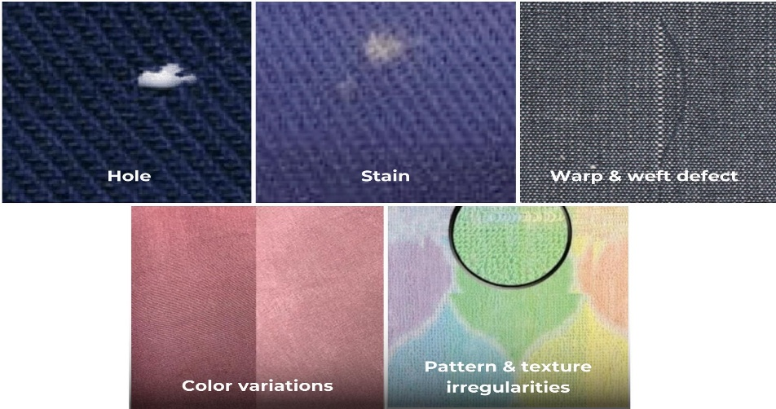

TASK 3: IMAGE REPRESENTATION – COMPARISON OF RGB, HSV AND GRAYSCALE

4. Introduction to Image Representation

Image representation is the method of describing and storing an image in a digital format so that a computer can process and analyse it. A digital image is made up of small elements called pixels. Each pixel stores information about the appearance of a particular location in the image.

When a camera captures fabric, it converts the light reflected from the fabric surface into digital information. The computer represents this information using numerical values. These values describe the colour and brightness of different parts of the fabric.

Image representation is an important stage in a Computer Vision system because the selected representation affects how easily the computer can identify different features. For example, a colour stain may be easier to detect using a colour representation, whereas a hole may be easier to analyse using grayscale intensity and texture information.

In the proposed textile inspection system, three important image representations are considered:

RGB colour representation.

HSV colour representation.

Grayscale representation.

Each representation has its own structure, advantages, limitations and applications. Selecting the correct representation is important for detecting holes, broken threads, oil stains, weaving irregularities and colour variations.

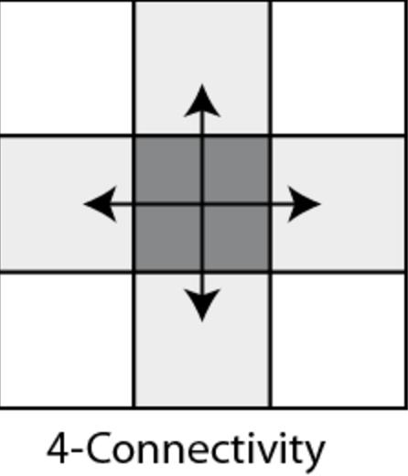

4.1 Digital Image and Pixels

A digital image is represented as a two-dimensional arrangement of pixels. Each pixel contains one or more numerical values depending on the image representation.

For example, a colour image may contain three values for every pixel, while a grayscale image generally contains one intensity value.

The dimensions of an image determine its number of pixels.

Therefore, the image contains 307,200 individual pixels.

Each pixel represents a small part of the fabric surface. When all pixels are combined, they form the complete digital image.

4.1.1 Pixel Values

A pixel value represents the brightness or colour information at a particular image location.

In an 8-bit grayscale image, the pixel values range from 0 to 255.

0 represents black.

255 represents white.

Values between 0 and 255 represent different shades of grey.

In an RGB image, each pixel contains three separate values representing red, green and blue components.

: 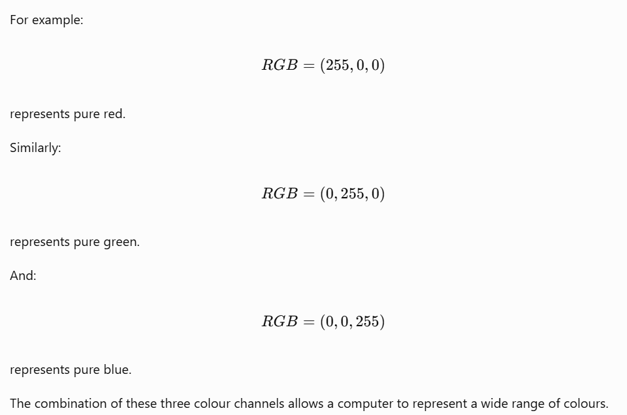

4.2 Approach A – RGB Colour Representation

4.2.1 Meaning of RGB

RGB stands for Red, Green and Blue. It is an additive colour model used to represent colour images using three primary colour channels.

Every pixel in an RGB image contains three values:

Red component.

Green component.

Blue component.

These three components are combined to produce the final colour of the pixel.

In a standard 8-bit RGB image, each channel has 256 possible intensity values ranging from 0 to 255.

Therefore, each pixel can represent:

\[ 256\times256\times256 \]

\[ =16,777,216text{ possible colours} \]

This large number of possible colours makes RGB suitable for capturing the natural appearance of fabric.

4.2.2 Structure of RGB Representation

An RGB image can be considered as three separate image channels.

TSFabrics: A Time-Series Fabric Dataset for Real-Time Defect Detection on Circular Knitting Machines | Scientific Data

Red channel

From Pixels to Insights: Exploring the Foundations of Computer Vision with MATLAB | by Aqsa Asif | Medium

Green channel

Digital image processing basics using OpenCV and python : | by Ahin Das | Medium

Blue channel

Weaving

Combined colour image

Figure 9: Conceptual representation of RGB colour channels.

The three channels work together to create the complete colour image.

For example, a white pixel is represented as:

\[ (255,255,255) \]

A black pixel is represented as:

\[ (0,0,0) \]

A yellow pixel can be represented as:

\[ (255,255,0) \]

A grey pixel has approximately equal values in all three channels.

4.2.3 Working Principle of RGB

The RGB colour model works by combining different intensities of red, green and blue light.

When the three components are combined at their maximum intensity, they produce white. When all three components have zero intensity, they produce black.

The colour of each pixel is determined by the relative intensity of the three channels.

For example, a red fabric region may have a high red value and lower green and blue values. A blue fabric region may have a high blue value.

The camera records these colour differences and stores them in the digital image.

4.2.4 RGB Representation in Textile Inspection

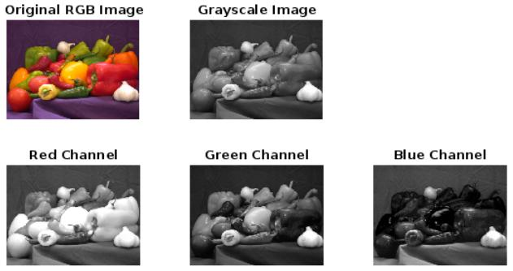

RGB is useful in textile inspection because fabric defects may create colour differences compared with the surrounding fabric.

A. Oil-stain detection

Oil stains may create dark, yellowish or brownish regions on fabric. RGB values can help identify these changes.

For example, a stain may have lower brightness values or a different relationship between red, green and blue components than the surrounding fabric.

However, if the fabric itself has a complicated colour pattern, direct RGB thresholding may produce false detections.

B. Colour-variation detection

RGB is useful for detecting changes in fabric colour. The system can compare the red, green and blue values of neighbouring regions.

If a region has significantly different colour values, it may indicate uneven dyeing or a colour variation.

C. Foreign material detection

Foreign fibres, dust or other materials may have a colour different from the surrounding fabric. RGB information can help distinguish such regions.

D. Stain analysis

Different stains may produce different colour combinations. Comparing all three channels can provide more information than using only brightness.

4.2.5 Advantages of RGB

Natural colour representation: RGB preserves the original colour appearance of the fabric.

Easy camera compatibility: Most digital cameras provide colour images that can be represented using RGB or a related channel order.

Colour analysis: The three channels help identify colour variations and stains.

Simple representation: The model is easy to understand and widely supported.

Detailed information: RGB retains more colour information than grayscale.

Useful for visual inspection: Operators can examine the original colour image when verifying a defect.

4.2.6 Limitations of RGB

Lighting sensitivity: RGB values can change when illumination changes.

Channel dependency: Brightness and colour information are mixed across the three channels.

Processing requirements: RGB images generally require more memory than grayscale images of the same dimensions.

Complex thresholds: A single RGB threshold may not work for different fabric colours.

Colour variation: Different cameras and lighting conditions may produce different RGB values for the same fabric.

4.2.7 Suitability of RGB for the Proposed System

RGB is suitable as the original image representation because it preserves the complete colour information captured by the camera.

It is particularly useful for detecting colour variations, coloured stains and foreign material. It should be retained even when other representations are used for individual detection operations.

For the proposed system, RGB is recommended as the original input image, while HSV and grayscale can be generated from it for specialised analysis.

4.3 Approach B – HSV Colour Representation

4.3.1 Meaning of HSV

HSV stands for Hue, Saturation and Value. It is a colour representation that separates colour-related information from brightness.

Unlike RGB, which stores colour using red, green and blue components, HSV describes colour using three properties:

Hue.

Saturation.

Value.

HSV is useful in image processing because it can make certain colour-analysis operations easier.

4.3.2 Components of HSV

A. Hue (H)

Hue represents the basic colour type. It describes whether a pixel is red, green, blue, yellow or another colour.

Hue is generally represented as an angle from 0° to 360° in the mathematical HSV model. Some software libraries use a scaled range for storage.

B. Saturation (S)

Saturation represents the strength or purity of a colour.

High saturation indicates a strong or vivid colour.

Low saturation indicates a pale or greyish colour.

Zero saturation represents a shade of grey.

C. Value (V)

Value represents the brightness of the colour.

A high value indicates a brighter pixel.

A low value indicates a darker pixel.

4.3.3 HSV Colour Representation Diagram

File:HSV color solid cylinder.png - Wikimedia Commons

commons.wikimedia.org

Figure 10: HSV colour model showing Hue, Saturation and Value.

4.3.4 Working Principle of HSV

HSV represents colour through three separate characteristics.

Consider a coloured fabric image. The hue channel describes the dominant colour of each pixel. The saturation channel describes how strong that colour is, while the value channel describes its brightness.

This separation is useful because some defects mainly affect colour, while others mainly affect brightness.

For example, a stain may change the colour of a fabric region without changing the surrounding fabric pattern. The hue and saturation channels may help reveal this difference.

However, HSV is not completely independent of illumination. Changes in lighting can still affect the saturation and value components, and hue becomes less reliable when saturation is very low.

4.3.5 HSV Representation in Textile Inspection

A. Oil-stain detection

Oil stains may produce colour and brightness changes. HSV allows the system to examine these characteristics separately.

For example, an oil stain on a light-coloured fabric may produce a change in hue and saturation. The value channel can also help identify darker stain regions.

B. Colour-variation detection

HSV is particularly useful when the objective is to compare the colour of neighbouring fabric regions.

The system can examine the hue difference between regions without relying only on brightness.

C. Foreign material detection

If a foreign fibre has a different colour from the surrounding fabric, hue and saturation information may help identify it.

D. Uneven dyeing detection

Uneven dyeing can create regions with different colour characteristics. HSV can help identify such regions by comparing their hue and saturation values.

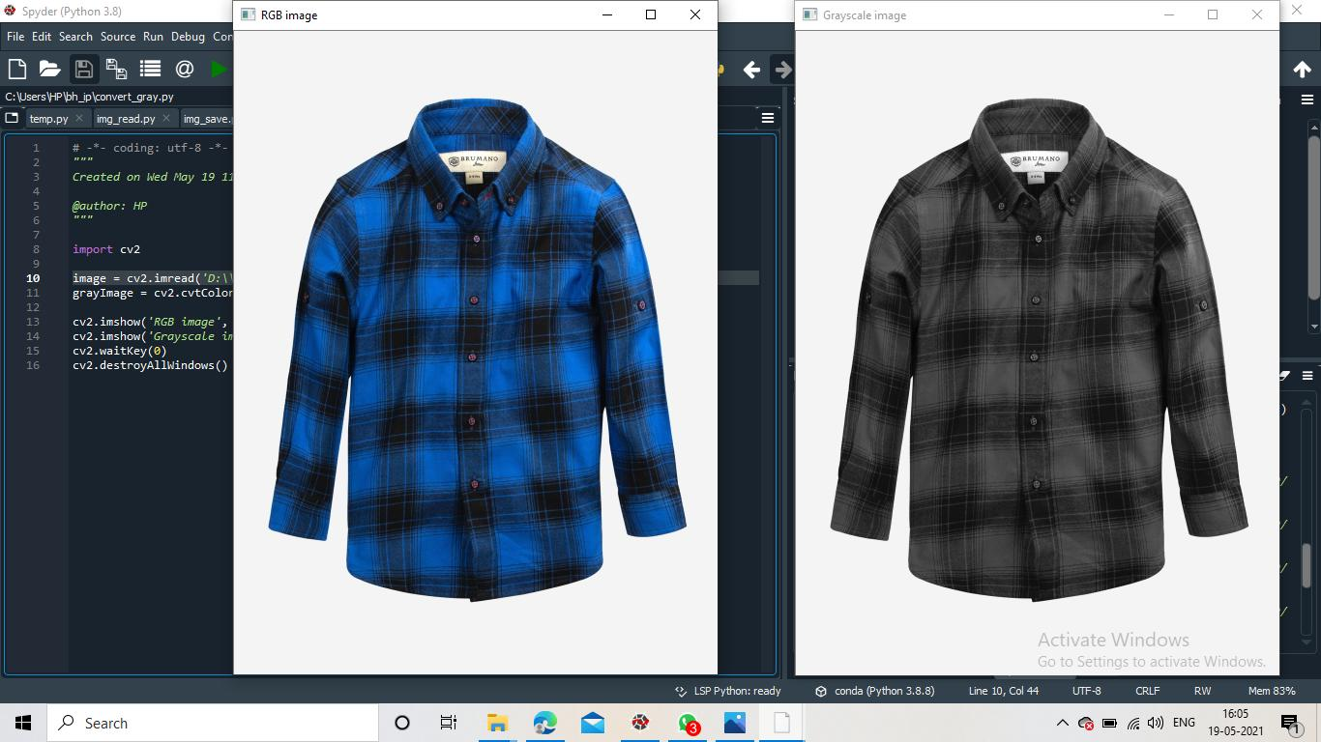

4.3.6 Advantages of HSV

Separation of colour and brightness: Hue and saturation describe colour, while value represents brightness.

Useful for colour detection: It can make colour-based thresholding easier.

Stain analysis: It can help distinguish certain stains from normal fabric.

Colour variation analysis: It supports comparison of colour differences between regions.

Flexible thresholding: Hue and saturation ranges can be selected for particular colour classes.

Useful preprocessing: HSV can be generated from the original RGB image using OpenCV.

4.3.7 Limitations of HSV

Lighting effects: Changes in illumination can affect the value and saturation channels.

Low-saturation instability: Hue is less meaningful for pixels with very low saturation.

Fabric texture: Natural variations in fabric colour may cause false detections.

Conversion requirement: The RGB image must be converted into HSV before analysis.

Threshold selection: Suitable HSV ranges must be selected and validated for different fabric colours.

4.3.8 Suitability of HSV for the Proposed System

HSV is recommended for colour-based defect analysis, especially oil stains, coloured contamination and uneven dyeing.

The proposed system should retain the original RGB image and convert a copy into HSV for colour analysis.

The system should not depend only on hue because some oil stains may be dark rather than strongly coloured. Combining hue, saturation and value information can provide a better representation of the suspicious region.

4.4 Approach C – Grayscale Image Representation

4.4.1 Meaning of Grayscale

Grayscale representation describes an image using different shades of grey instead of full colour.

Each pixel contains a single intensity value that represents its brightness.

In a standard 8-bit grayscale image, pixel values range from 0 to 255.

0 represents black.

255 represents white.

Values between 0 and 255 represent different shades of grey.

Grayscale representation reduces the complexity of an image because it stores only one intensity value per pixel.

4.4.2 Structure of Grayscale Representation

Elegant gray cotton fabric texture background

Grayscale fabric

A fragment of a torn burlap texture as a background.

Possible hole region

Figure 11: Grayscale representation of fabric and a possible defect region.

4.4.3 Conversion from RGB to Grayscale

A colour image can be converted into grayscale using a weighted combination of the red, green and blue channels.

A commonly used formula is:

\[ Gray=0.299R+0.587G+0.114B \]

Where:

\(R\) = red channel value.

\(G\) = green channel value.

\(B\) = blue channel value.

The weights account for the different contributions of the three colour channels to perceived brightness.

Example calculation

Consider a pixel with the following RGB values:

\[ R=100,\quad G=150,\quad B=200 \]

Substituting into the grayscale equation:

\[ Gray=0.299(100)+0.587(150)+0.114(200) \]

\[ =29.9+88.05+22.8 \]

\[ =140.75 \]

Therefore, the grayscale value is approximately:

\[ \boxed{141} \]

This means that the colour pixel is represented by a single grey intensity value of approximately 141.

4.4.4 Working Principle of Grayscale

In grayscale representation, colour information is removed and only brightness information is retained.

Each pixel is represented using one intensity value. This makes several image-processing operations simpler.

For example, edge detection can be performed on grayscale images to identify boundaries. Thresholding can separate dark and bright regions. Texture analysis can examine intensity patterns in the fabric.

4.4.5 Grayscale Representation in Textile Inspection

A. Hole detection

A hole may appear as a region with a different intensity from the surrounding fabric. Grayscale images can simplify the analysis of these intensity differences.

B. Broken-thread detection

Broken threads may create gaps or discontinuities in the fabric structure. Grayscale edge detection can help identify these irregularities.

C. Weaving-irregularity detection

Weaving defects often change the regular intensity pattern of fabric. Grayscale texture analysis can be used to detect such variations.

D. Oil-stain detection

Dark oil stains may create a noticeable intensity difference from the surrounding fabric. Grayscale thresholding may help highlight these regions.

However, the specified oil-stain contrast is only 5–8 grey levels. Therefore, the image must preserve sufficient intensity detail, and the lighting must be controlled.

4.4.6 Advantages of Grayscale

Reduced memory: Only one intensity channel is stored per pixel.

Faster processing potential: Many operations can be performed without handling three separate colour channels.

Simple thresholding: Dark and bright regions can be separated using intensity values.

Edge detection: Common edge-detection methods work effectively with grayscale images.

Texture analysis: Intensity variations can be used to study fabric patterns.

Suitable for CPU-based systems: Grayscale processing can reduce computational requirements.

4.4.7 Limitations of Grayscale

Loss of colour information: Different colours may become similar shades of grey.

Limited colour-defect detection: It cannot independently identify defects that differ only by colour.

Lighting sensitivity: Brightness changes can affect intensity-based detection.

Similar intensity values: Some defects may have the same brightness as the surrounding fabric.

Low-contrast difficulty: Faint stains may be difficult to distinguish from normal fabric variations.

4.4.8 Suitability of Grayscale for the Proposed System

Grayscale is recommended for detecting defects that produce differences in brightness, texture and edge structure.

It is especially useful for hole detection, broken-thread analysis and weaving irregularities.

However, it should not replace RGB completely because colour variations and some oil stains may require colour information.

Therefore, grayscale should be used as an additional processing representation generated from the original RGB image.

4.5 Comparison of RGB, HSV and Grayscale
Feature | RGB | HSV | Grayscale
Full form | Red, Green, Blue | Hue, Saturation, Value | Grey intensity
Channels | 3 | 3 | 1
Main information | Colour components | Colour and brightness properties | Brightness
Colour preservation | Yes | Yes, in transformed form | No
Brightness separation | Not directly separated | Value channel | Entire image
Memory requirement | Higher | Similar to RGB when all channels are stored | Lower
Colour detection | Suitable | Very useful | Not suitable
Edge detection | Possible | Possible | Commonly used
Texture analysis | Possible | Possible | Very useful
Lighting sensitivity | Yes | Yes | Yes
Main textile application | Original colour and shade analysis | Stains and colour variation | Holes, edges and texture

4.6 Numerical Comparison of Memory Requirements

Image representation affects the amount of memory required to store an image.

For a standard 8-bit image:

RGB uses 3 bytes per pixel.

HSV uses 3 bytes per pixel when all three 8-bit channels are stored.

Grayscale uses 1 byte per pixel.

The memory requirement can be calculated using:

\[ \text{Memory}=\text{Width}\times\text{Height}\times\text{Bytes per pixel} \]

Consider a 640 × 480 image.

A. RGB memory

\[ 640\times480\times3 \]

\[ =921,600\text{ bytes} \]

B. HSV memory

\[ 640\times480\times3 \]

\[ =921,600\text{ bytes} \]

C. Grayscale memory

\[ 640\times480\times1 \]

\[ =307,200\text{ bytes} \]
Representation | Bytes per pixel | Memory requirement
RGB | 3 | 921,600 bytes
HSV | 3 | 921,600 bytes
Grayscale | 1 | 307,200 bytes

Therefore, grayscale requires approximately one-third of the memory needed for RGB or HSV at the same image dimensions and bit depth.

4.7 Image Representation for the Given Textile Inspection System

The proposed textile inspection system must identify five major defect types. Each defect has different visual characteristics. Therefore, using only one image representation may not be sufficient.

The recommended strategy is to capture and preserve the original colour image, then generate different representations according to the inspection requirement.
Defect type | Recommended representation | Reason
Hole | Grayscale | Intensity and boundary differences
Broken thread | Grayscale | Edge and texture discontinuities
Oil stain | HSV and grayscale | Colour, saturation and brightness changes
Weaving irregularity | Grayscale | Texture and pattern analysis
Colour variation | RGB and HSV | Comparison of colour information

4.7.1 Recommended Processing Sequence

Original RGB image from camera

Image preprocessing and correction

RGB

Colour variation

HSV

Stain analysis

Grayscale

Texture and edges

Feature extraction and defect detection

Defect classification and final decision

Figure 12: Recommended image-representation workflow for textile inspection.

4.8 Implementation Using Python and OpenCV

OpenCV is an open-source computer vision library that provides functions for reading, displaying and processing digital images.

The following Python program demonstrates how an image can be represented using RGB, HSV and grayscale.

4.8.1 Explanation of the Program

Step 1 – Importing libraries

import cv2import matplotlib.pyplot as plt

The OpenCV library is imported for image processing. Matplotlib is imported to display the different image representations.

Step 2 – Reading the image

image = cv2.imread("fabric.jpg")

This statement reads the fabric image from the specified file.

Step 3 – Converting BGR to RGB

rgb = cv2.cvtColor(image, cv2.COLOR_BGR2RGB)

OpenCV normally reads colour images in BGR channel order. This statement converts the image into RGB order for correct display using Matplotlib.

Step 4 – Converting RGB/BGR image into HSV

hsv = cv2.cvtColor(image, cv2.COLOR_BGR2HSV)

This statement converts the image into HSV representation. It separates hue, saturation and value information.

Step 5 – Converting into grayscale

gray = cv2.cvtColor(image, cv2.COLOR_BGR2GRAY)

This statement converts the original colour image into a single-channel grayscale image.

Step 6 – Displaying the images

Matplotlib displays the original colour representation, HSV image and grayscale image so that their differences can be examined.

Important: The HSV image is a transformed colour representation. For visual interpretation, it is often more useful to display the H, S and V channels separately rather than displaying the HSV array directly as though it were an RGB image.

4.9 Practical Considerations

4.9.1 Lighting Conditions

The given lighting range is 500–3,000 lux. A large change in illumination may affect the RGB, HSV and grayscale values.

The system should use controlled lighting to maintain stable image conditions. It should also avoid direct reflections from the fabric surface.

4.9.2 Fabric Colour

Different fabric colours may require different thresholds. A threshold suitable for white cotton fabric may not work for black or coloured fabric.

Therefore, the system should use suitable settings for each fabric category and validate them using representative samples.

4.9.3 Low-Contrast Oil Stains

The oil-stain contrast is specified as 5–8 grey levels. This is a small intensity difference.

The system should preserve the original image information and avoid excessive filtering or compression. Controlled illumination and suitable image bit depth are important for maintaining the visibility of these stains.

4.9.4 Processing Time

The system uses a four-core CPU without a GPU. Processing every colour channel separately may increase the computational workload.

Therefore, the system should use RGB where colour is important, HSV for selected colour-analysis operations and grayscale for intensity-based processing.

4.10 Final Recommendation

For the proposed textile inspection system, RGB should be used as the original image representation because it preserves complete colour information.

HSV should be used for detecting colour differences, stains and uneven dyeing. Grayscale should be used for analysing holes, broken threads, edges and weaving irregularities.

The system should not discard the original RGB image after conversion. Keeping the original image allows the operator to verify detections and provides a useful record for future analysis.

A combined representation strategy is recommended because different fabric defects produce different visual changes. This approach provides more flexibility than relying on only RGB, HSV or grayscale.

TASK 4 – PIXEL CONNECTIVITY IN DIGITAL IMAGE PROCESSING

4.1 Introduction

Pixel connectivity is an important concept in digital image processing and Computer Vision. A digital image consists of small elements called pixels (picture elements). Each pixel represents a particular intensity or colour value.

In fabric inspection, pixel connectivity is used to identify and group neighbouring pixels that belong to the same defect. For example, a hole in fabric may appear as a group of connected dark pixels, while an oil stain may appear as a connected region with a different intensity or colour from the surrounding fabric.

By analysing pixel connectivity, a Computer Vision system can identify the size, shape, location and boundaries of fabric defects.

4.2 Meaning of Pixel Neighbourhood

A pixel neighbourhood refers to the pixels surrounding a particular pixel. In a two-dimensional image, every pixel can have neighbouring pixels around it.

Consider a pixel located at position \((x,y)\). Its neighbouring pixels can be identified using different connectivity rules.

There are three important types of pixel connectivity:

4-connectivity

8-connectivity

m-connectivity (mixed connectivity)

4.3 4-Connectivity

In 4-connectivity, a pixel is connected only to its four immediate horizontal and vertical neighbours.

For a pixel \(P(x,y)\), the four neighbours are:

Top: \((x-1,y)\)

Bottom: \((x+1,y)\)

Left: \((x,y-1)\)

Right: \((x,y+1)\)

Counting Spree

Example:

Consider the following binary image:

0 1 0

1 1 1

0 1 0

Here, the central pixel is connected to the pixels above, below, left and right.

The diagonal pixels are not considered connected under 4-connectivity.

Advantages:

Simple to understand and implement.

Useful for detecting defects connected horizontally or vertically.

Reduces accidental connections between diagonal pixels.

Limitations:

Diagonally touching pixels are treated as separate regions.

Some thin or diagonal fabric defects may not be grouped correctly.

Application in textile inspection:

4-connectivity can be used to identify continuous horizontal or vertical defects, such as broken threads and narrow lines in woven fabric.

4.4 8-Connectivity

In 8-connectivity, a pixel is connected to all eight surrounding pixels, including diagonal neighbours.

For a central pixel \(P(x,y)\), its neighbours include:

Top, bottom, left and right.

Top-left, top-right, bottom-left and bottom-right.

BLOB Analysis in Image Processing – Grétar Már Kjartansson – Electrical- and Control Engineer M.Sc.

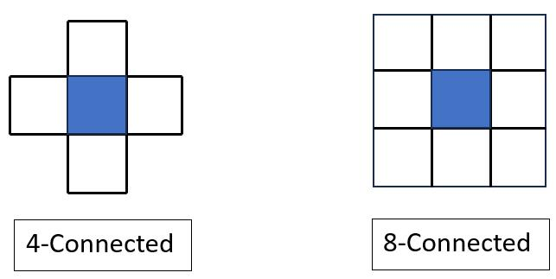Example:

1 0 1

0 1 0

1 0 1

Under 8-connectivity, all four corner pixels are diagonally connected to the central pixel.

Under 4-connectivity, these corner pixels are not connected to the central pixel.

Advantages:

Detects diagonal connections.

Useful for identifying irregularly shaped defects.

Helps group pixels that form diagonal lines or curved regions.

Limitations:

May combine separate defects that touch only at their corners.

Can create unwanted connections between nearby regions.

Application in textile inspection:

8-connectivity is useful for detecting irregular holes, diagonal broken threads, weaving irregularities and connected stain regions.

4.5 m-Connectivity (Mixed Connectivity)

m-connectivity is also called mixed connectivity. It combines the concepts of 4-connectivity and diagonal connectivity.

In m-connectivity, two pixels are considered connected if:

They are 4-neighbours, or

They are diagonal neighbours and their common 4-neighbours do not contain pixels belonging to the same foreground set.

This rule helps avoid unnecessary connections between diagonal pixels.

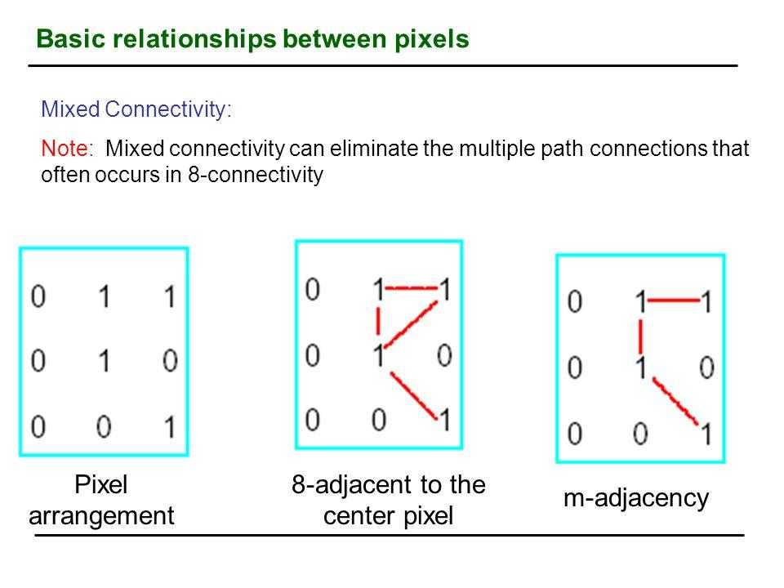

Example:

Consider two diagonal pixels. If one or both common horizontal or vertical neighbours are also foreground pixels, the diagonal connection may be excluded.

This prevents ambiguous connections when pixels touch diagonally.

Advantages:

Avoids some unwanted diagonal connections.

Provides a more controlled way of grouping pixels.

Useful when distinguishing nearby defects.

Limitations:

More complex than 4-connectivity and 8-connectivity.

Requires additional checking of common neighbours.

Application in textile inspection:

m-connectivity can help distinguish between two nearby defects and prevent them from being incorrectly identified as one large defect.

4.6 Comparison of Pixel Connectivity
Feature | 4-connectivity | 8-connectivity | m-connectivity
Neighbours considered | 4 | 8 | 4 and selected diagonal
Diagonal connection | No | Yes | Conditional
Complexity | Low | Low | Medium
Diagonal defect detection | Limited | Good | Controlled
Unwanted merging | Less likely | More likely | Reduced in ambiguous cases
Main use | Horizontal/vertical regions | Irregular regions | Avoiding ambiguous connections

4.7 Connected Component Analysis

Connected component analysis is a technique used to identify and label separate groups of connected pixels in a binary image.

In fabric inspection, the system first converts an image into a binary image. Defect pixels are represented by 1, while normal fabric pixels are represented by 0.

The connected component algorithm then groups neighbouring foreground pixels into separate regions.

Example:

Input binary image:

1 1 0 0 0

1 1 0 1 1

0 0 0 1 1

0 1 1 0 0

The image contains three separate groups of connected foreground pixels under 4-connectivity.

Each group can receive a unique label:

1 1 0 0 0

1 1 0 2 2

0 0 0 2 2

0 3 3 0 0

Here:

Label 1 represents the first connected region.

Label 2 represents the second connected region.

Label 3 represents the third connected region.

This allows the system to analyse each defect separately.

4.8 Importance of Pixel Connectivity in Textile Inspection

Pixel connectivity plays an important role in identifying fabric defects accurately.

1. Hole detection

A hole may appear as a group of pixels that differ significantly from the surrounding fabric. Connectivity helps group those pixels into one defect region.

2. Broken thread detection

Broken threads may form thin horizontal, vertical or diagonal patterns. Different connectivity methods help identify these patterns.

3. Oil stain detection

Oil stains generally form irregular regions. 8-connectivity can help group diagonal and irregularly shaped stain pixels.

4. Weaving irregularity detection

Connectivity analysis helps identify groups of pixels that form unusual patterns compared with the normal fabric texture.

5. Defect size measurement

After grouping connected pixels, the system can calculate the area of each defect and determine whether it requires further inspection.

4.9 Implementation Using Python and OpenCV

Python and OpenCV can be used to perform connected component analysis on fabric images.

The following program converts an image into grayscale, applies thresholding and identifies connected regions.

import cv2

import matplotlib.pyplot as plt

# Read the fabric image

img = cv2.imread("fabric.jpg")

if img is None:

print("Image not found")

else:

# Convert image to grayscale

gray = cv2.cvtColor(img, cv2.COLOR_BGR2GRAY)

# Convert grayscale image into binary image

_, binary = cv2.threshold(

gray, 120, 255, cv2.THRESH_BINARY_INV

)

# Apply connected component analysis

num_labels, labels, stats, centroids = (

cv2.connectedComponentsWithStats(

binary, connectivity=8

)

)

print("Number of regions:", num_labels - 1)

# Display labelled regions

output = cv2.applyColorMap(

(labels * 30 % 255).astype("uint8"),

cv2.COLORMAP_JET

)

plt.figure(figsize=(12, 5))

plt.subplot(1, 2, 1)

plt.imshow(binary, cmap="gray")

plt.title("Binary Image")

plt.subplot(1, 2, 2)

plt.imshow(cv2.cvtColor(output, cv2.COLOR_BGR2RGB))

plt.title("Connected Components")

plt.show()Explanation of the Program

cv2.imread() loads the fabric image.

cv2.cvtColor() converts the image into grayscale.

cv2.threshold() converts the grayscale image into a binary image.

cv2.connectedComponentsWithStats() identifies connected pixel regions.

num_labels gives the total number of labels, including the background.

stats provides information such as the area and bounding box of each region.

centroids gives the centre coordinates of each connected region.

Matplotlib displays the binary image and labelled regions.

Note: The threshold value of 120 is only an example. It must be adjusted according to the actual fabric image and lighting conditions. The program demonstrates connectivity analysis; it does not independently guarantee that every connected region is a real fabric defect.

4.10 Advantages of Connectivity Analysis

Helps identify separate defect regions.

Supports automatic defect counting.

Makes defect area measurement easier.

Helps detect irregular and diagonal patterns.

Reduces the need for manual inspection.

Can be implemented using basic image-processing libraries.

4.11 Limitations of Connectivity Analysis

Results depend on the quality of the binary image.

Noise may create false connected regions.

Closely located defects may merge into one region.

Small defects may disappear during preprocessing.

Connectivity alone cannot determine the actual type of defect.

Therefore, connectivity analysis should be combined with preprocessing, feature extraction and defect classification techniques.

4.12 Conclusion

Pixel connectivity is an essential technique in digital image processing for identifying groups of neighbouring pixels. The three major connectivity methods are 4-connectivity, 8-connectivity and m-connectivity. Each method has different advantages depending on the shape and arrangement of pixels. In textile fabric inspection, these methods help identify holes, broken threads, oil stains and weaving irregularities. Connected component analysis further helps calculate the number, area and location of defect regions. By combining connectivity analysis with other Computer Vision techniques, a more reliable automated fabric inspection system can be developed.

TASK 5 – IMAGE ACQUISITION TECHNIQUES FOR TEXTILE FABRIC INSPECTION

5.1 Introduction

Image acquisition is the first and one of the most important stages of a Computer Vision system. It is the process of capturing an image of a real-world object using a camera and converting it into digital data that can be processed by a computer.

In textile fabric inspection, image acquisition is used to capture the moving fabric surface and identify defects such as holes, broken threads, oil stains, colour variations and weaving irregularities.

The quality of the captured image directly affects the accuracy of defect detection. If the image is blurred, poorly illuminated or has insufficient resolution, even an advanced image-processing algorithm may fail to identify small defects.

For the proposed textile inspection system, the given operating conditions include:

Fabric width: 1,000 mm

Camera field of view: 1,200 × 400 mm

Conveyor speed: 0.6 m/s

Smallest defect size: 1.5 mm

Camera mounting height: 700 mm

Lighting range: 500–3,000 lux

Maximum decision time: 0.5 seconds

These conditions must be considered when selecting the camera, lens, lighting arrangement and image-capture method.

5.2 Basic Image Acquisition Process

The image acquisition process consists of several stages.

Fabric Surface

Object to be inspected

Lighting System

Illuminates the fabric

Camera and Lens

Captures the reflected light

Image Sensor

Converts light into electrical signals

Digital Image

Image is transferred to the computer

Image Processing and Defect Detection

Explanation of the stages

Fabric surface: The fabric moves along the conveyor and passes through the inspection area.

Lighting system: A suitable light source illuminates the fabric so that defects become visible.

Camera and lens: The lens focuses the reflected light onto the camera sensor.

Image sensor: The sensor converts the received light into electrical signals.

Digital image: The signals are converted into digital pixel values.

Image processing: The computer analyses the captured image and identifies possible defects.

5.3 Types of Cameras Used in Image Acquisition

Different types of cameras are used in industrial Computer Vision systems. The selection depends on the speed of the object, image resolution, inspection area and defect size.

1. Area-Scan Camera

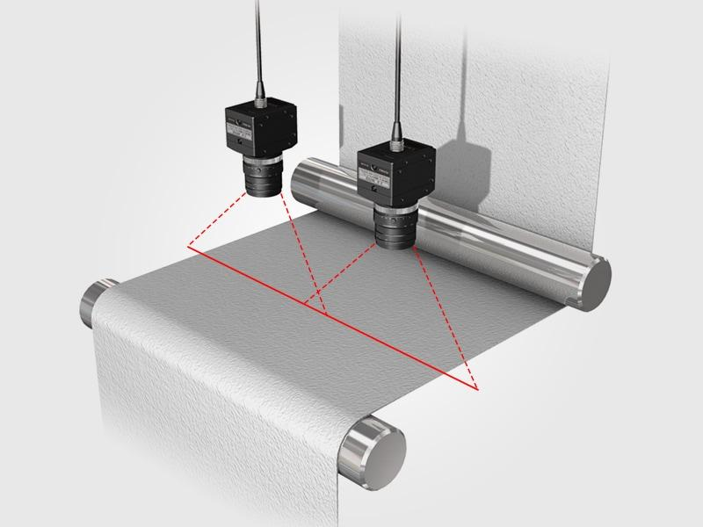

An area-scan camera captures a complete two-dimensional image in a single exposure. It records multiple rows and columns of pixels at the same time.

Working:

The camera captures the entire visible fabric region.

The image sensor records the light intensity at each pixel.

The captured frame is transferred to the computer.

Image-processing algorithms analyse the frame.

Advantages:

Captures a complete image at once.

Easy to set up and use.

Suitable for inspecting stationary objects.

Useful for laboratory testing and smaller inspection areas.

Limitations:

Fast-moving fabric may produce motion blur.

Large fabric surfaces may require multiple cameras or repeated captures.

Frame rate and exposure time must be selected carefully.

2. Line-Scan Camera

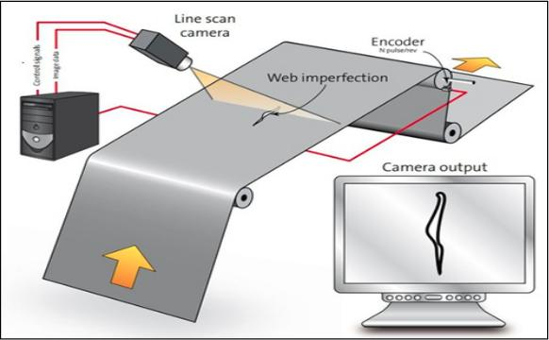

A line-scan camera captures one line of pixels at a time. As the fabric moves along the conveyor, the camera captures successive lines and combines them to create a complete two-dimensional image.

Working:

The fabric moves continuously under the camera.

The camera captures one line across the fabric width.

The conveyor movement brings the next section into the inspection position.

The camera captures another line.

The computer combines all captured lines to form a complete image.

Advantages:

Suitable for continuous inspection of moving fabric.

Can inspect long fabric rolls.

Provides detailed images across the fabric width.

Reduces the need to capture large full-frame images repeatedly.

Limitations:

Requires accurate synchronization with conveyor movement.

Incorrect line timing can stretch or compress the image.

Installation and calibration can be more complex.

Application: A line-scan camera is particularly suitable for continuous textile inspection because the fabric moves continuously along the conveyor.

3. Area-Scan and Line-Scan Camera Comparison
Feature | Area-scan camera | Line-scan camera
Image capture | Complete 2D frame | One line at a time
Object movement | Can inspect stationary objects | Well suited to continuous movement
Image formation | Single frame | Combines successive lines
Synchronization | Frame triggering | Line triggering and conveyor synchronization
Long fabric rolls | May require repeated frames | Suitable for continuous inspection
Setup | Generally simpler | Requires careful synchronization

Recommendation: For continuous inspection of a moving fabric roll, a line-scan camera is a strong option. An area-scan camera can still be used for a prototype if the frame rate, exposure and image quality are sufficient.

5.4 Types of Shutters Used in Cameras

A shutter controls how long the camera sensor receives light during image capture. It is important when inspecting moving fabric because a long exposure can produce blurred images.

1. Rolling Shutter

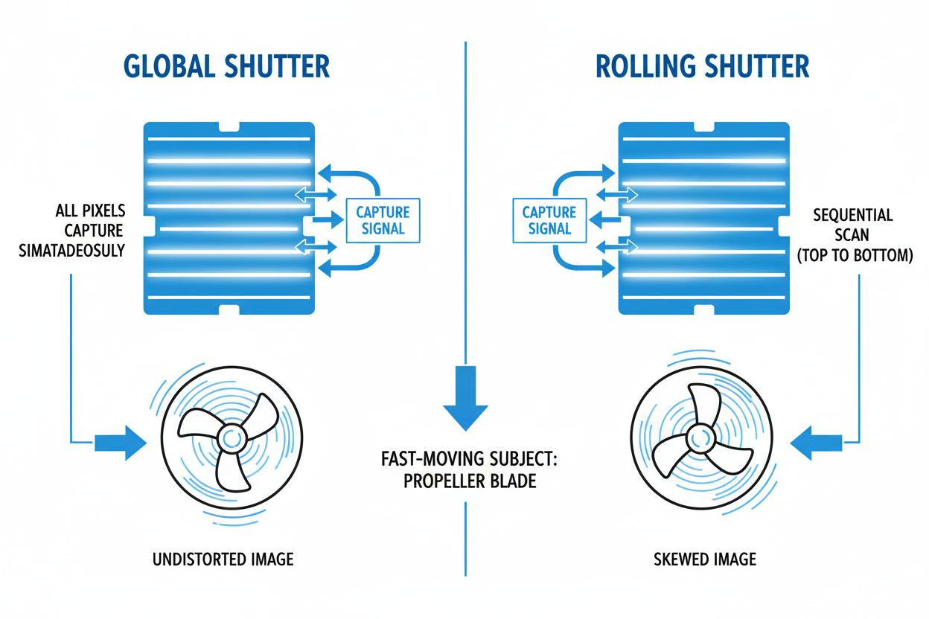A rolling shutter captures different rows of an image at slightly different times.

Working:

The camera starts capturing the first row.

It then captures the remaining rows one after another.

The complete image is formed from these rows.

Advantages:

Common in many digital cameras.

Can be less expensive.

Suitable for stationary objects and controlled conditions.

Limitations:

Fast movement can cause image distortion.

Straight lines may appear tilted or bent.

Moving fabric may not be represented accurately.

Application: It may be used for slow-moving fabric, but it is less suitable when high-speed and accurate inspection is required.

2. Global Shutter

A global shutter captures all pixels of the image at approximately the same instant.

Working:

All sensor pixels begin exposure together.

Each pixel captures light during the same exposure period.

The complete image is read from the sensor.

Advantages:

Reduces motion-related geometric distortion.

Suitable for moving objects.

Provides more consistent images for measurement.

Useful for industrial inspection.

Limitations:

Some global-shutter cameras may be more expensive.

Camera selection must still consider resolution, frame rate and sensitivity.

Application: A global-shutter camera is a suitable choice for inspecting fabric moving on a conveyor when using an area-scan camera.

5.5 Importance of Exposure Time

Exposure time is the duration for which the camera sensor receives light.

When fabric moves during image capture, excessive exposure time causes motion blur. Motion blur makes defect boundaries unclear and can affect defect measurement.

The approximate motion blur is calculated using:

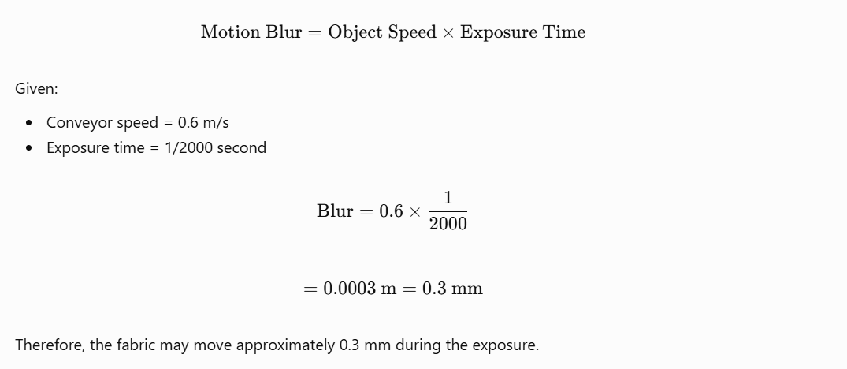Comparison of exposure times:
Exposure time | Approximate motion blur
1/1000 s | 0.6 mm
1/2000 s | 0.3 mm
1/5000 s | 0.12 mm
1/10000 s | 0.06 mm

A shorter exposure reduces motion blur. However, it also allows less light to reach the sensor. Therefore, sufficient illumination is required.

Recommendation: A short exposure, such as 1/5000 second, can be considered as an initial test setting. The final exposure must be selected by testing actual fabric images and checking whether the smallest defects remain visible.

5.6 Lighting Techniques for Fabric Inspection

Lighting is an important part of image acquisition. Proper lighting makes defects visible and reduces unwanted shadows and reflections.

The proposed system has a specified lighting range of 500–3,000 lux. The lighting arrangement should provide consistent illumination across the full fabric width.

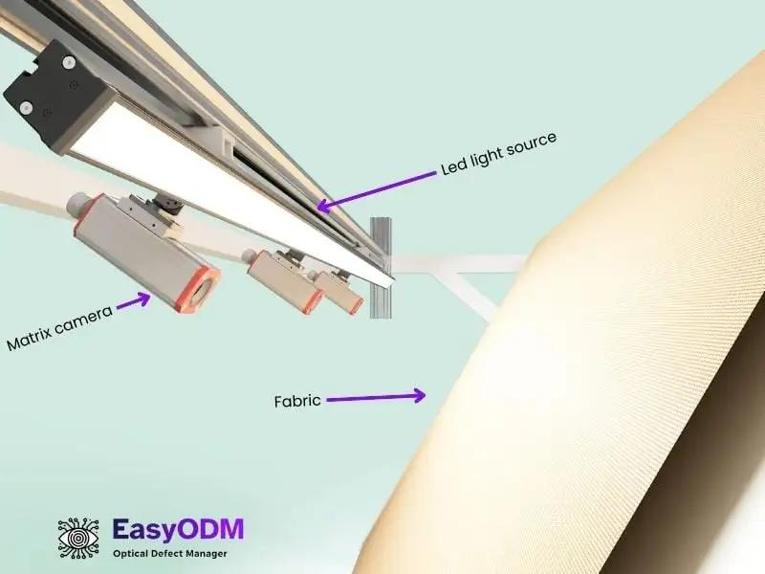

1. Front Lighting

Front lighting illuminates the fabric from the camera side.

Advantages:

Easy to install.

Useful for observing surface colour.

Helps identify stains and surface contamination.

Limitations:

May create shadows.

Uneven lighting can affect defect detection.

Reflective surfaces may produce glare.

Application: Suitable for detecting oil stains, colour differences and surface contamination.

2. Backlighting

Backlighting places a light source behind the fabric.

Working:

Light passes through the fabric.

Holes and thin regions allow more light to pass through.

These regions appear brighter than surrounding fabric in the captured image.

Advantages:

Useful for identifying holes and missing material.

Makes some openings easier to distinguish.

Can improve contrast between the fabric and defects.

Limitations:

Not suitable for every type of surface defect.

Fabric thickness and transparency affect the result.

May not clearly show oil stains or colour differences.

Application: Particularly useful for detecting holes and openings in fabric.

3. Diffuse Lighting

Diffuse lighting spreads light evenly over the fabric surface.

Advantages:

Reduces harsh shadows.

Reduces unwanted reflections.

Provides more uniform illumination.

Helps maintain consistent image quality.

Limitations:

May reduce contrast for certain surface defects.

Requires suitable light positioning and intensity.

Application: Useful for general fabric inspection, particularly when the surface contains texture and uneven reflections.

4. LED Lighting

LED lights are commonly used in industrial vision systems because their intensity and position can be controlled.

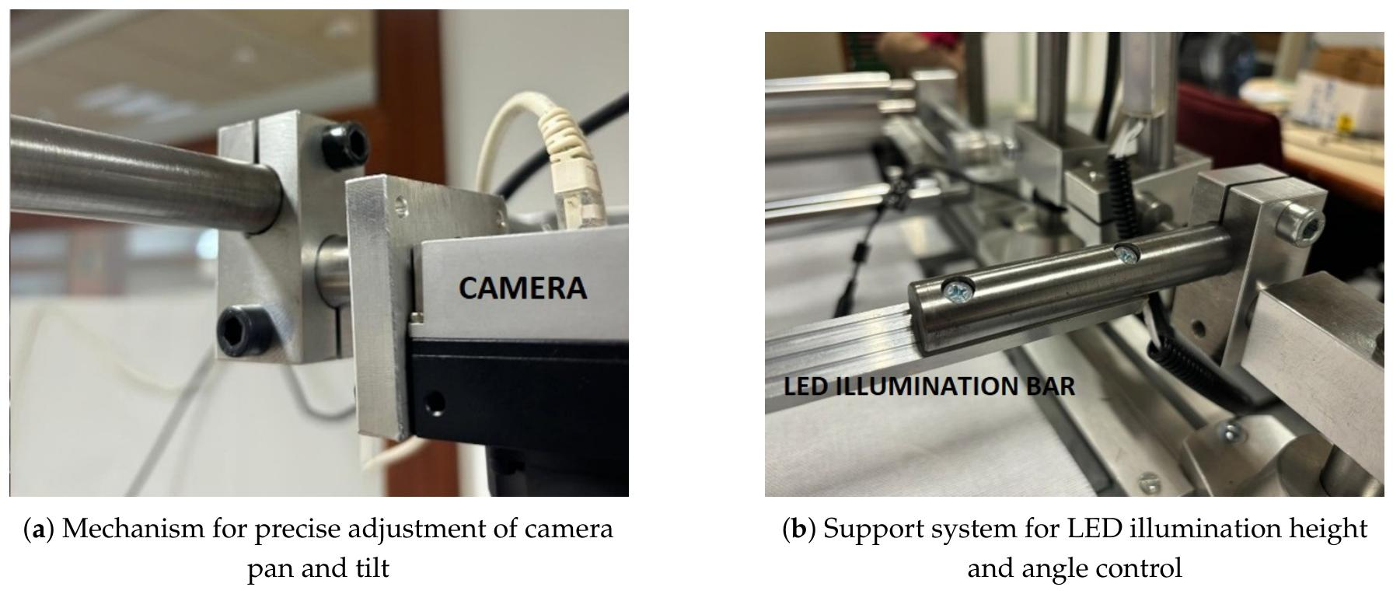

Advantages:

Energy efficient.

Available in different colours.

Can provide stable illumination.

Suitable for continuous operation.

Application: LED bar lights or area lights can be arranged across the fabric width to provide consistent illumination.

5.7 Camera Placement and Field of View

Camera placement determines how much of the fabric is visible in each captured image.

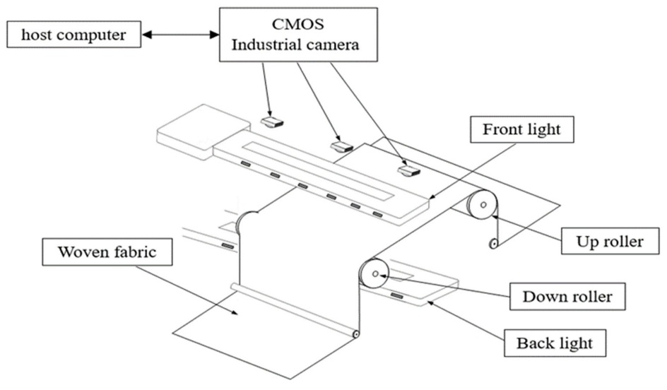

For the proposed system:

Fabric width = 1,000 mm.

Camera field of view = 1,200 × 400 mm.

Camera mounting height = 700 mm.

The horizontal field of view is greater than the fabric width.

[ 1200-1000=200 mm]

Therefore, the camera has a total horizontal margin of 200 mm, or approximately 100 mm on each side when the fabric is centred.

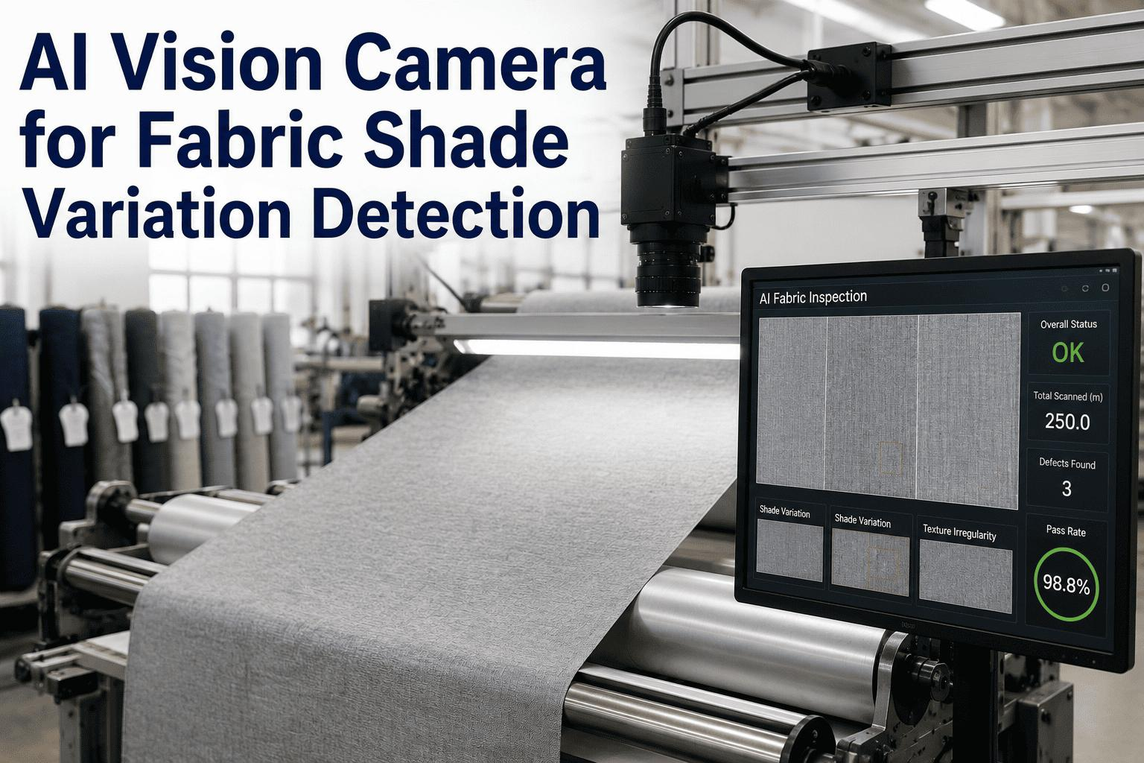

Important considerations:

The camera should be positioned securely above the inspection area.

The fabric should remain within the camera's field of view.

The camera should be aligned to avoid unnecessary perspective distortion.

The lens should provide sufficient focus across the fabric width.

Lighting should cover the entire inspection area uniformly.

The camera should be protected from dust, vibration and unwanted external light.

5.8 Camera Resolution and Defect Visibility

Camera resolution determines the number of pixels used to represent the captured image.

Higher resolution allows smaller details to be represented using more pixels.

For example, consider a horizontal field of view of 1,200 mm.

The approximate pixel size is:

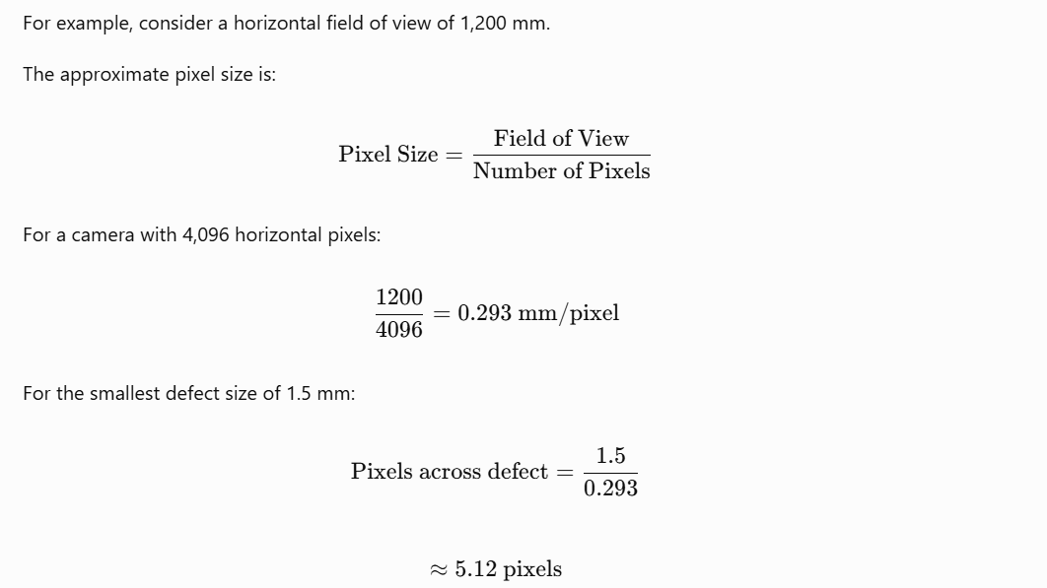

This means a 1.5 mm defect would occupy approximately five pixels across its width, assuming suitable focus and alignment.
Horizontal resolution | Pixel size | Pixels across a 1.5 mm defect
1,280 pixels | 0.938 mm | 1.60
2,448 pixels | 0.490 mm | 3.06
4,096 pixels | 0.293 mm | 5.12

Observation: The 4,096-pixel option provides better representation of small defects than the lower-resolution options. However, the actual detection performance also depends on lighting, lens quality, focus, contrast and image-processing methods.

5.9 Synchronization with Conveyor Movement

In industrial inspection, the camera must capture images at the correct time while the fabric is moving.

Synchronization ensures that the camera captures the correct fabric region without missing sections or producing incorrectly scaled images.

For a line-scan camera, the line capture rate must match the fabric movement and the required image resolution.

.

Example: Fabric Movement

Given:

Conveyor speed = 0.6 m/s.

Camera-to-marker distance = 0.3 m.

The time taken by the fabric to travel from the camera position to the marker is:

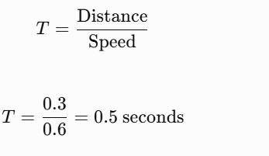

Therefore, the system has approximately 0.5 seconds between inspection and reaching the marker position.

This time must be considered when designing the complete process of image acquisition, defect detection, decision-making and marker activation.

5.10 Factors Affecting Image Acquisition Quality

Several factors can affect the quality of captured fabric images.
Factor | Effect on image | Possible solution
Poor lighting | Defects become difficult to identify | Use suitable controlled lighting
Excessive exposure | Motion blur | Reduce exposure time
Low resolution | Small defects may be missed | Select a suitable sensor resolution
Incorrect focus | Blurred fabric details | Adjust lens focus
Camera vibration | Unstable images | Use a rigid mounting arrangement
Uneven illumination | Different brightness across the image | Use uniform lighting
External light | Unwanted brightness variations | Use an enclosure or light shielding
Incorrect triggering | Missing or distorted image sections | Synchronize camera and conveyor

5.11 Recommended Image Acquisition Setup

Based on the operating conditions, the following setup can be considered for the proposed textile inspection system.
Component | Recommended arrangement
Camera type | Line-scan camera for continuous inspection, or suitable area-scan camera for a prototype
Shutter | Global shutter for an area-scan camera inspecting moving fabric
Resolution | High enough to represent a 1.5 mm defect with several pixels
Lens | Industrial lens matched to the required field of view
Camera height | 700 mm, subject to lens and field-of-view calibration
Lighting | Controlled LED lighting
Additional lighting | Backlighting for hole detection, where practical
Exposure | Short exposure selected through testing
Synchronization | Encoder or suitable conveyor-trigger arrangement
Image transfer | Gigabit Ethernet connection

This is a proposed design, not a tested hardware configuration. Final selection requires checking the camera specifications, lens compatibility, actual image quality and processing speed.

5.12 Conclusion

Image acquisition is the foundation of an effective Computer Vision system. In textile fabric inspection, it involves selecting a suitable camera, lens, shutter, lighting arrangement and image-capture method. Area-scan cameras capture complete frames, while line-scan cameras capture successive lines and are suitable for continuous inspection of moving fabric. Global shutters help reduce motion-related distortion, and short exposure times reduce motion blur.

TASK 6 – IMAGE SAMPLING AND SPATIAL RESOLUTION IN COMPUTER VISION

6.1 Introduction

Image sampling is an important process in digital image processing. It converts a continuous real-world image into a digital image consisting of a finite number of pixels.

A camera captures light reflected from an object and converts it into digital information. The continuous image is divided into small elements called pixels. Each pixel represents a particular location in the image and stores information about brightness or colour.

In textile fabric inspection, image sampling helps represent the fabric surface digitally so that a Computer Vision system can identify small defects such as holes, broken threads, stains and weaving irregularities.

The quality of image sampling directly affects the ability of the system to detect small defects. If the sampling resolution is too low, small defects may not be represented clearly.

6.2 Meaning of Image Sampling

Image sampling is the process of dividing a continuous image into a finite grid of pixels.

Each pixel represents a small area of the original image.

For example, when a camera captures a fabric surface, the image is divided into rows and columns of pixels. The computer processes these pixels to identify different patterns and defects.

Computer Vision - Image Formation.pptx

slideshare.net

Example:

Consider an image with a resolution of 4 × 4 pixels.

P11 P12 P13 P14

P21 P22 P23 P24

P31 P32 P33 P34

P41 P42 P43 P44

The image contains:

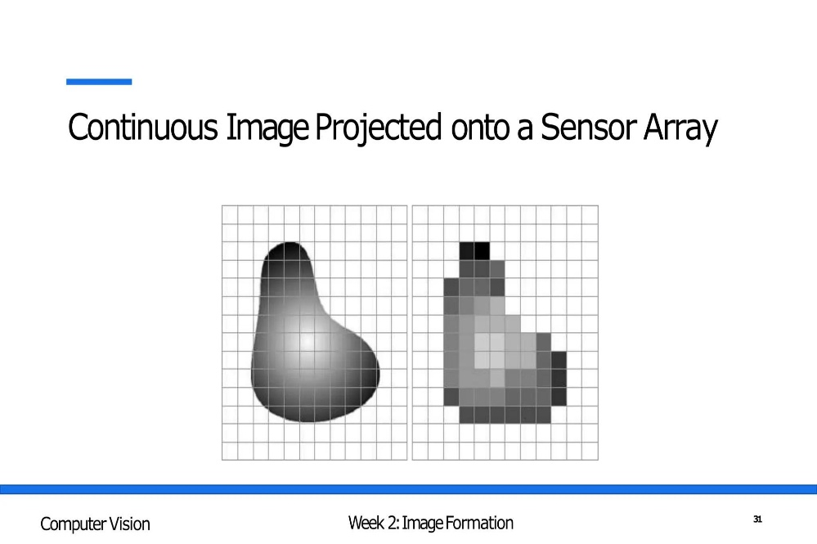

Each pixel stores information about a small part of the fabric image.

When the number of pixels increases, the image can represent more spatial details, provided the camera optics and image quality are adequate.

6.3 Meaning of Spatial Resolution

Spatial resolution refers to the ability of an imaging system to distinguish small details in an image.

It describes how much physical area is represented by each pixel or how many pixels are used to represent a given physical area.

In textile inspection, spatial resolution is important because the system must detect small defects accurately.

For example, a 1.5 mm hole must occupy enough pixels to be distinguishable from the surrounding fabric.

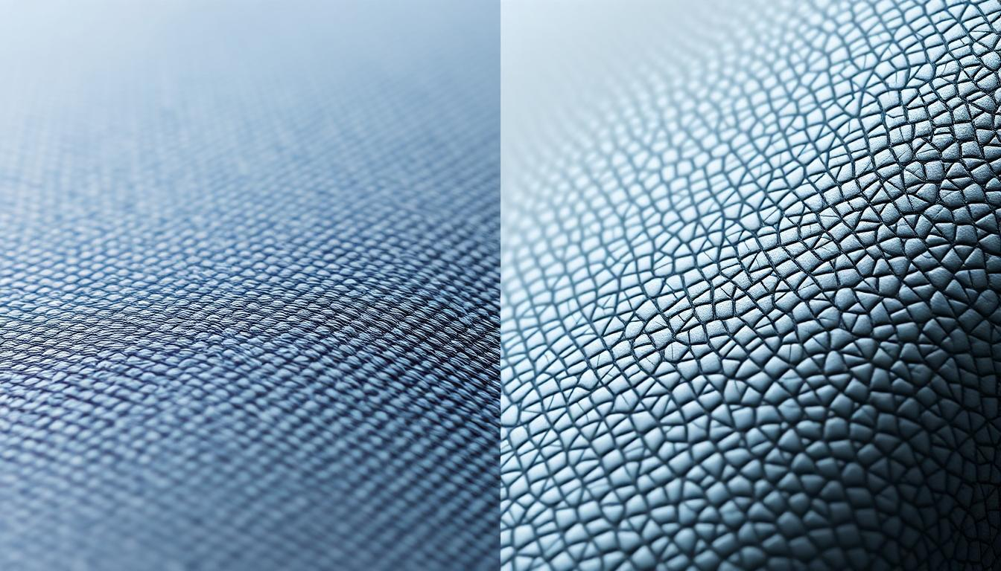

A higher spatial resolution generally provides more detail, while a lower spatial resolution may cause small defects to disappear or become difficult to identify.

AI Image Upscaling for E-Commerce: How to Get Print-Ready Resolution from Any Photo | Pixelus

pixelus.io

Importance of spatial resolution

Helps identify small fabric defects.

Improves the visibility of fine threads.

Supports accurate defect-size measurement.

Helps distinguish nearby defects.

Improves the quality of image analysis.

6.4 Types of Image Resolution

1. Spatial Resolution

Spatial resolution indicates the amount of spatial detail represented in an image.

It depends on the number of pixels and the physical area covered by the camera.

Application: It determines whether a small hole or broken thread can be represented using sufficient pixels.

2. Temporal Resolution

Temporal resolution refers to how frequently images are captured over time.

It is important when inspecting moving fabric.

For example, a camera capturing 30 frames per second records 30 images every second.

A higher capture rate can help reduce the possibility of missing defects moving through the inspection area. However, the required frame rate also depends on conveyor speed, field of view and overlap between captured frames.

3. Spectral Resolution

Spectral resolution refers to the ability of a camera to distinguish different wavelengths or bands of light.

A normal RGB camera captures red, green and blue colour information.

Special cameras may capture additional wavelength bands, such as infrared or ultraviolet.

Application: Spectral imaging may help identify stains or material differences that are difficult to observe using ordinary visible-light images.

6.5 Relationship Between Pixels and Physical Size

The number of pixels used to represent a physical object depends on the camera resolution and field of view.

The following formula is used:

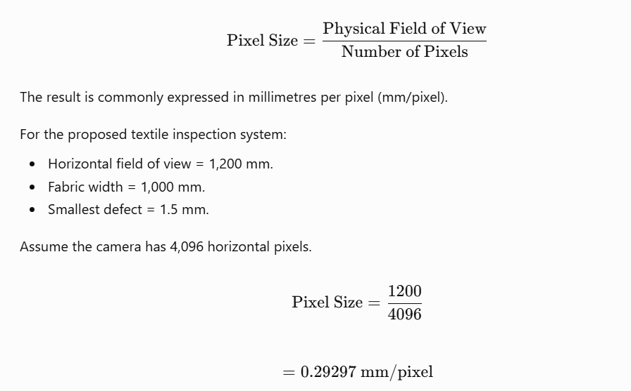

Therefore, one pixel represents approximately 0.293 mm of the fabric width.

The number of pixels covering a 1.5 mm defect is:



Thus, the smallest defect occupies approximately five pixels across its width.

6.6 Comparison of Different Camera Resolutions

Consider three camera resolutions with the same horizontal field of view of 1,200 mm.

Case 1: 1,280 horizontal pixels

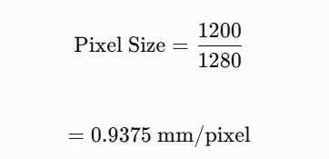

For a 1.5 mm defect:

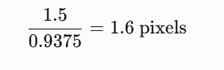

The defect occupies only about 1.6 pixels.

This may not provide sufficient information for reliable detection and measurement.

Case 2: 2,448 horizontal pixels

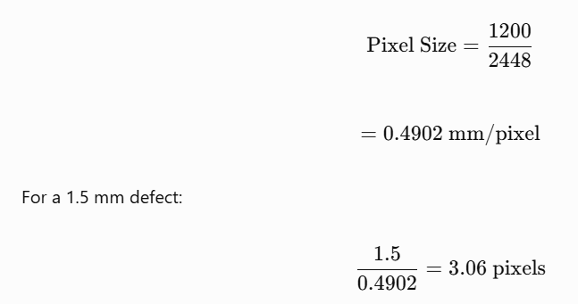

The defect occupies approximately three pixels.

This provides more information than the first option, but accurate measurement may still be difficult.

Case 3: 4,096 horizontal pixels

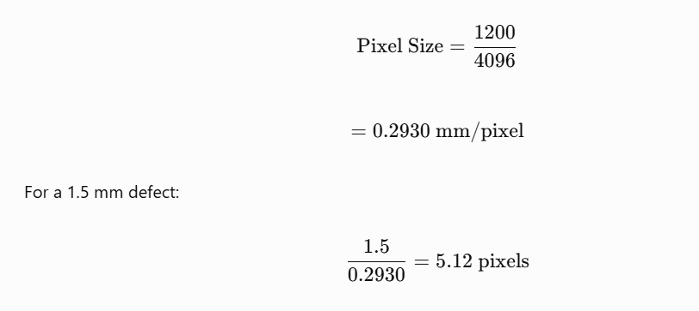

The defect occupies approximately five pixels.

This option provides the best spatial representation among the three choices.

Comparison table
Horizontal resolution | Pixel size | Pixels across 1.5 mm defect
1,280 pixels | 0.9375 mm | 1.60
2,448 pixels | 0.4902 mm | 3.06
4,096 pixels | 0.2930 mm | 5.12

Pixels representing a 1.5 mm defect

Comparison at a 1,200 mm horizontal field of view.

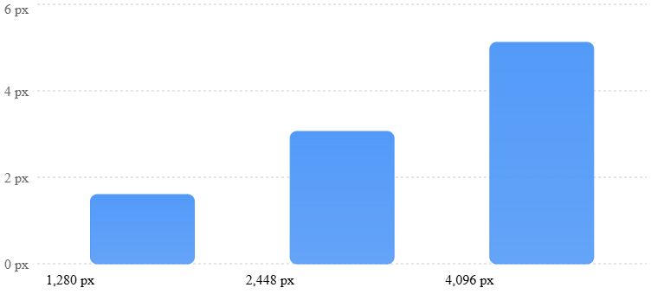

Observation: The 4,096-pixel option provides the highest spatial detail among the three options. However, actual detection depends on image quality, focus, illumination, contrast and the defect-detection algorithm.

6.7 Sampling Rate and Defect Detection

Sampling rate determines how frequently the image is captured or sampled.

For moving fabric, the camera must capture enough image information to avoid missing sections of the fabric.

The conveyor speed and image-capture frequency determine how far the fabric travels between captures.

The relationship is:

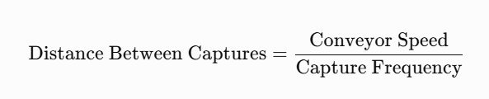

For example, assume:

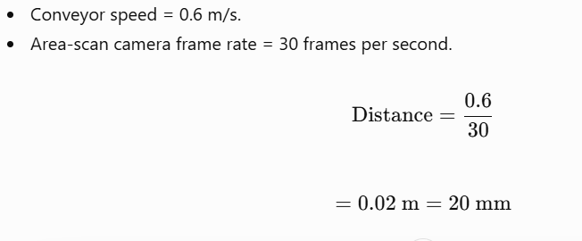

Therefore, the fabric moves 20 mm between successive frames.

If the inspection system uses an area-scan camera, the camera's field of view and frame overlap must be considered to ensure complete coverage.

For a line-scan camera, the line acquisition rate must be synchronized with conveyor movement to obtain the required vertical spatial resolution.

6.8 Under-Sampling and Over-Sampling

1. Under-Sampling

Under-sampling occurs when an image is captured with insufficient sampling points to represent the details of the original object.

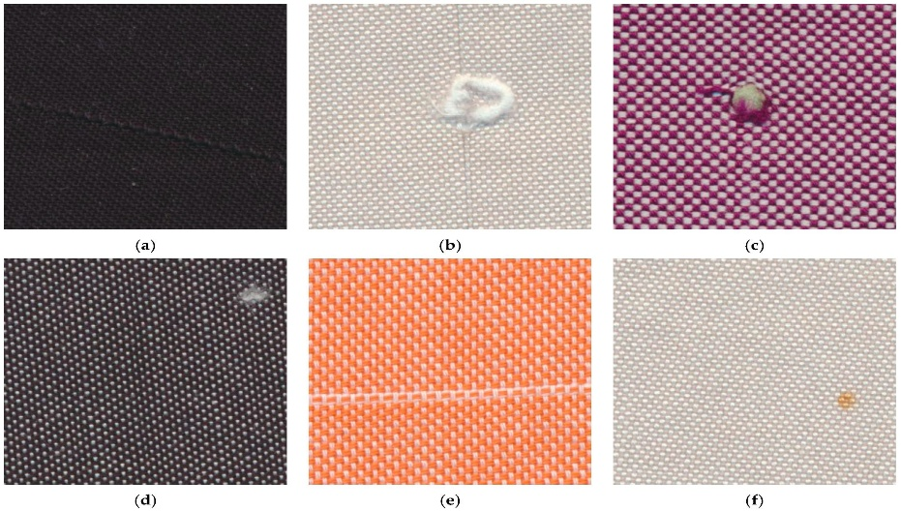

Effects of under-sampling:

Small defects may disappear.

Fine thread patterns may become unclear.

Defect boundaries may be inaccurate.

Nearby defects may merge.

The system may produce incorrect measurements.

Example: If a 1.5 mm defect occupies only one or two pixels, the system may not identify its shape correctly.

2. Over-Sampling

Over-sampling occurs when an image is sampled at a much higher resolution than required for the intended application.

Advantages:

Provides more image details.

Supports more accurate boundary analysis.

Helps represent small defects.

Limitations:

Requires more storage space.

Increases processing requirements.

May increase image-transfer time.

Can reduce the number of images processed per second.

Example: A very high-resolution camera may capture detailed fabric images, but the CPU may not be able to process every image within the required decision time.

Therefore, an appropriate balance between image quality and processing speed is necessary.

6.9 Nyquist Sampling Principle

The Nyquist sampling principle states that a signal must be sampled at a frequency at least twice its highest frequency component to avoid aliasing under ideal sampling conditions.

In image processing, this principle is important when representing repeating patterns and fine textures.

For textile fabric, woven threads form repeating spatial patterns. If the camera resolution is insufficient to represent these patterns, aliasing may occur.

Aliasing can produce incorrect patterns, false lines or visual distortions in the digital image.

Example:

When a fabric contains closely spaced threads, insufficient spatial sampling may cause the thread pattern to appear different from the actual pattern.

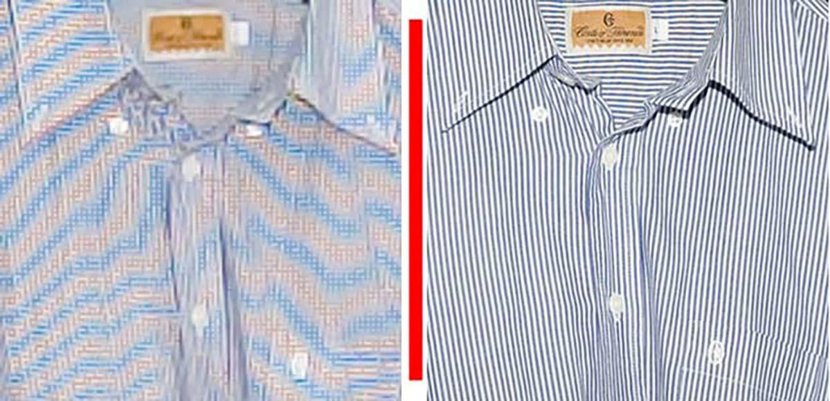

Methods to reduce aliasing:

Select a suitable camera resolution.

Use an appropriate optical lens.

Avoid unnecessary image resizing.

Apply suitable optical filtering where required.

Validate the image using actual fabric samples.

6.10 Factors Affecting Spatial Resolution
Factor | Effect
Camera resolution | Determines the number of available pixels
Field of view | A wider field of view gives fewer pixels per millimetre at the same sensor resolution
Lens quality | Affects the amount of detail reaching the sensor
Camera distance | Affects the field of view and image scale
Focus | Poor focus reduces visible detail
Camera vibration | Can cause blurred images
Lighting | Poor lighting reduces defect visibility
Image resizing | May remove important small details

6.11 Python Program to Understand Image Sampling

The following Python program demonstrates how an image changes when its resolution is reduced and then enlarged.

import cv2

import matplotlib.pyplot as plt

# Read the fabric image

img = cv2.imread("fabric.jpg")

if img is None:

print("Image not found")

else:

# Convert BGR image to RGB

img = cv2.cvtColor(img, cv2.COLOR_BGR2RGB)

# Get original image dimensions

height, width = img.shape[:2]

print("Original dimensions:", width, "x", height)

# Reduce image resolution

small = cv2.resize(img, (width // 4, height // 4))

# Enlarge the reduced image

enlarged = cv2.resize(

small,

(width, height),

interpolation=cv2.INTER_NEAREST

)

# Display images

plt.figure(figsize=(12, 5))

plt.subplot(1, 2, 1)

plt.imshow(img)

plt.title("Original Image")

plt.subplot(1, 2, 2)

plt.imshow(enlarged)

plt.title("Reduced and Enlarged Image")

plt.show()

Explanation of the Program

cv2.imread() reads the fabric image.

cv2.cvtColor() converts the image from BGR to RGB.

img.shape provides the image dimensions.

cv2.resize() reduces the image width and height to one-fourth.

The reduced image is enlarged using nearest-neighbour interpolation.

Matplotlib displays the original and enlarged images.

Expected result: The original image contains more spatial detail, while the reduced and enlarged image appears pixelated.

This demonstrates how reducing the number of sampling points can remove important details.

6.12 Recommended Sampling Resolution for the Proposed System

Based on the given operating conditions, the camera should provide enough pixels across the smallest defect.

The three options can be evaluated as follows:

1,280 pixels: The smallest defect occupies approximately 1.6 pixels, which is likely insufficient for reliable detection.

2,448 pixels: The defect occupies approximately 3.06 pixels, providing better representation.

4,096 pixels: The defect occupies approximately 5.12 pixels, providing the best representation among the three options.

Therefore, a camera with approximately 4,096 horizontal pixels is a reasonable starting point for the proposed design.

However, five pixels across a defect do not automatically guarantee reliable detection. The system should be tested using real fabric samples containing defects of known dimensions.

6.13 Advantages of Proper Image Sampling

Improves the representation of small defects.

Helps preserve fabric texture details.

Supports accurate defect measurement.

Improves the quality of image-processing operations.

Helps distinguish closely located defects.

Provides better input for defect classification algorithms.

6.14 Limitations of Image Sampling

Higher resolution requires more storage.

Large images require more processing time.

Insufficient sampling can cause loss of important details.

Excessive sampling may increase system cost.

Image quality is also affected by lens focus and illumination.

Incorrect sampling can introduce aliasing and distortion.

6.15 Conclusion

Image sampling and spatial resolution are important concepts in Computer Vision because they determine how accurately a real-world object is represented as a digital image. In textile fabric inspection, proper sampling is necessary to detect small defects such as holes, broken threads and weaving irregularities. The comparison of different camera resolutions shows that higher horizontal resolution provides more pixels across a defect. Under-sampling may cause small defects to disappear, while excessive sampling can increase processing and storage requirements. Therefore, selecting a suitable camera resolution based on the smallest defect size, field of view and processing capacity is essential for developing an effective automated fabric inspection system.

TASK 7 – IMAGE QUANTIZATION AND INTENSITY LEVELS IN COMPUTER VISION

7.1 Introduction

Image quantization is an important process in digital image processing. It converts continuous intensity values into a limited number of discrete intensity levels.

When a camera captures an image, the light reflected from an object is converted into electrical signals. These signals are converted into digital values by the camera sensor and analogue-to-digital conversion process.

A digital image contains pixels, and each pixel stores a numerical value representing its brightness or colour.

Quantization determines how many different intensity values can be represented in the digital image.

In textile fabric inspection, image quantization is important for identifying defects such as oil stains, colour variations, holes and broken threads. Proper quantization helps preserve the intensity differences between defective and normal fabric regions.

7.2 Meaning of Image Quantization

Image quantization is the process of converting a continuous range of intensity values into a limited number of discrete values.

For example, the brightness of a real-world image can vary continuously. A computer cannot store every possible brightness value, so it represents brightness using a fixed number of digital levels.

In an 8-bit grayscale image, each pixel can represent 256 intensity levels, ranging from 0 to 255.

0 represents black.

255 represents white.

Values between 0 and 255 represent different shades of gray.

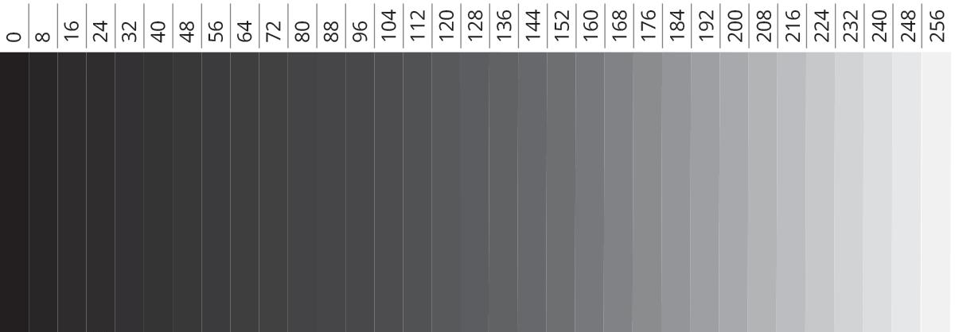Example:
Pixel value | Intensity representation
0 | Black
50 | Dark gray
100 | Medium-dark gray
150 | Medium-light gray
200 | Light gray
255 | White

7.3 Difference Between Sampling and Quantization

Sampling and quantization are two important processes used to convert a continuous image into a digital image.

Feature | Sampling | Quantization
Meaning | Divides the image into pixels | Assigns discrete intensity values
Controls | Spatial resolution | Intensity resolution
Concern | Number and position of pixels | Number of brightness levels
Example | 1024 × 768 pixels | 256 grayscale levels
Main effect | Represents spatial details | Represents brightness differences

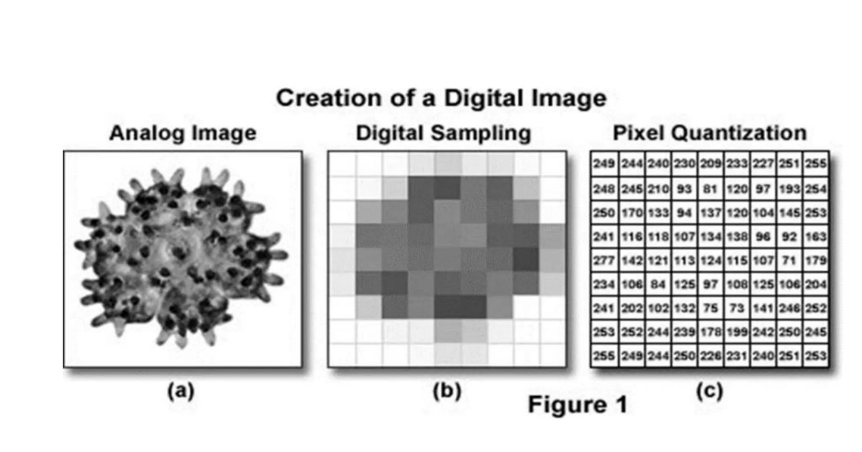

Simple explanation:

Sampling decides how many pixels are used to represent the image.

Quantization decides how many intensity values each pixel can store.

Both are necessary for converting a continuous image into a digital image.

7.4 Meaning of Bit Depth

Bit depth refers to the number of bits used to represent the intensity or colour value of each pixel channel.

The number of possible intensity levels is calculated using:

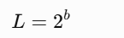

Where:

L = Number of intensity levels.

b = Number of bits.

For example, if an image uses 8 bits:

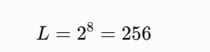

Therefore, an 8-bit grayscale image contains 256 intensity levels.

7.5 Different Bit Depths

1. 4-bit Image

A 4-bit image uses four bits to represent each pixel.

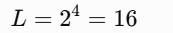

Therefore, it can represent 16 intensity levels.

Advantages:

Requires less storage.

Simple to process.

Suitable for applications requiring fewer intensity levels.

Limitations:

Limited brightness representation.

Small intensity differences may disappear.

Not suitable for subtle fabric-stain detection without careful validation.

2. 8-bit Image

An 8-bit image uses eight bits to represent each grayscale pixel.

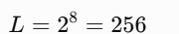

It represents intensity values from 0 to 255.

Advantages:

Provides a good range of grayscale values.

Supported by most image-processing libraries.

Requires moderate storage.

Suitable for many general fabric-inspection applications.

Limitations:

May not preserve very small intensity differences in challenging low-contrast conditions.

Provides fewer levels than higher-bit-depth images.

3. 12-bit Image

A 12-bit image uses twelve bits to represent each pixel.

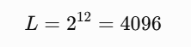

It can represent 4096 different intensity levels.

Advantages:

Provides more intensity levels.

Helps preserve subtle brightness differences.

Useful for low-contrast inspection applications.

Provides more flexibility during image enhancement.

Limitations:

Requires more storage than an 8-bit image when stored in a wider data format.

May increase processing requirements.

Requires a compatible camera and processing pipeline.

Comparison of Bit Depths
Bit depth | Number of intensity levels
4-bit | 16
5-bit | 32
6-bit | 64
8-bit | 256
10-bit | 1,024
12-bit | 4,096
16-bit | 65,536

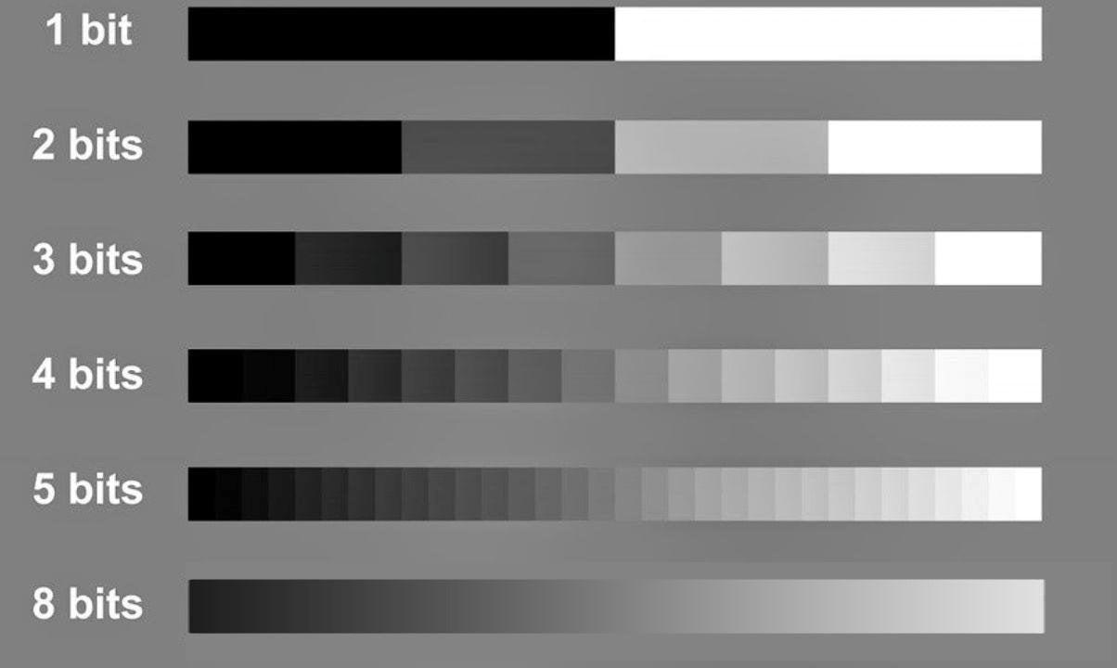

7.6 Quantization Error

Quantization error is the difference between the original continuous intensity value and the quantized intensity value.

During quantization, the original intensity is rounded or mapped to one of the available discrete levels.

The difference between the original and represented values is called quantization error.

Where:

e = Quantization error.

Xq = Quantized intensity value.

x = Original intensity value.

Example:

Suppose the original intensity value is 126.7, and the quantized value is 127.

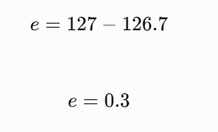

Therefore, the quantization error is 0.3 intensity units.

Smaller quantization errors generally preserve image intensity information more accurately.

7.7 Uniform Quantization

Uniform quantization divides the available intensity range into equal intervals.

Each interval is assigned a representative intensity value.

For example, an 8-bit grayscale image has an intensity range of 0 to 255.

If the image is divided into fewer levels, several original intensity values are mapped to the same quantized value.

Advantages:

Easy to implement.

Simple mathematical representation.

Requires less computational complexity.

Useful for basic digital image processing.

Limitations:

May remove small intensity differences.

Can create visible banding.

May reduce the visibility of low-contrast defects.

7.8 Importance of Quantization in Textile Fabric Inspection

Quantization plays an important role in identifying fabric defects because different defects may have small brightness or colour differences compared with normal fabric.

The proposed textile inspection system must detect oil stains with a contrast of approximately 5–8 grayscale levels.

This is a relatively small intensity difference, so the choice of bit depth is important.

1. Oil Stain Detection

Oil stains may produce only a small change in image intensity.

If quantization is too coarse, the stain and surrounding fabric may be represented using the same intensity value.

This makes the stain difficult to identify.

2. Colour Variation Detection

Different fabric regions may contain slight colour differences.

Suitable image quantization helps preserve those differences for further colour analysis.

3. Hole Detection

Holes may produce strong brightness differences, particularly when backlighting is used.

Quantization should preserve these intensity differences.

4. Broken Thread Detection

Broken threads may create small changes in texture and brightness.

Sufficient intensity resolution helps preserve the information required for further processing.

7.9 Effect of Reduced Bit Depth on Oil Stain Detection

Consider a fabric image where the normal fabric intensity is 120 and the oil-stain intensity is 114.

The difference is:

120-114=6

Therefore, the oil stain has a contrast difference of 6 grayscale levels.

If an 8-bit image is used, the two intensity values can be represented separately:

Normal fabric = 120.

Oil stain = 114.

However, if the image is reduced to fewer intensity levels, the values may be mapped to the same quantized value.

This can make the stain less visible.

Important: The actual result depends on the quantization method and mapping intervals. Reducing bit depth does not always make two particular values identical, but it increases the possibility of losing small intensity differences.

7.10 Comparison of 8-bit and 12-bit Images for the Proposed System

The proposed textile inspection system must detect oil stains with a contrast of approximately 5–8 grayscale levels.

An 8-bit image provides 256 intensity levels, while a 12-bit image provides 4096 intensity levels.
Feature | 8-bit image | 12-bit image
Intensity levels | 256 | 4096
Brightness representation | Moderate | Finer
Storage requirement | Lower | Higher
Processing requirement | Generally lower | May be higher
Low-contrast analysis | Suitable if validated | More flexibility
Hardware compatibility | Very common | Requires compatible hardware

Recommendation:

A 12-bit camera is worth considering if the system needs to preserve subtle intensity variations in oil stains. An 8-bit camera may still be suitable if controlled lighting, image quality and defect detection are validated using actual fabric samples.

Higher bit depth alone does not guarantee better detection. The camera sensor must also have sufficient dynamic range and low noise.

7.11 Storage Requirement Based on Bit Depth

Image bit depth also affects storage requirements.

Consider a grayscale image with:

Width = 4096 pixels.

Height = 3000 pixels.

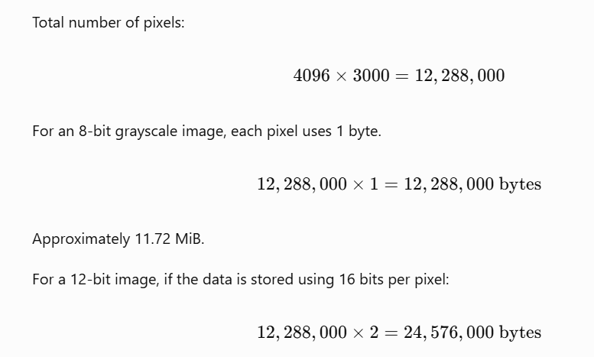

Approximately 23.44 MiB.
Image format | Approximate storage per image
8-bit grayscale | 11.72 MiB
12-bit stored in 16-bit containers | 23.44 MiB

This shows that higher bit-depth images can require more storage. The actual storage depends on the camera's packing format and compression method.

7.12 Python Program to Demonstrate Quantization

The following program demonstrates how reducing the number of intensity levels changes a grayscale image.

import cv2

import numpy as np

import matplotlib.pyplot as plt

# Read fabric image

img = cv2.imread("fabric.jpg")

if img is None:

print("Image not found")

else:

# Convert to grayscale

gray = cv2.cvtColor(img, cv2.COLOR_BGR2GRAY)

# Quantization function

def quantize_image(image, levels):

step = 256 // levels

quantized = (image // step) * step

return quantized.astype(np.uint8)

# Create images with different levels

img_16 = quantize_image(gray, 16)

img_4 = quantize_image(gray, 4)

# Display results

plt.figure(figsize=(12, 5))

plt.subplot(1, 3, 1)

plt.imshow(gray, cmap="gray")

plt.title("Original 8-bit Image")

plt.subplot(1, 3, 2)

plt.imshow(img_16, cmap="gray")

plt.title("16 Intensity Levels")

plt.subplot(1, 3, 3)

plt.imshow(img_4, cmap="gray")

plt.title("4 Intensity Levels")

plt.show()Explanation of the Program

cv2.imread() reads the fabric image.

cv2.cvtColor() converts the image into grayscale.

The quantize_image() function reduces the number of intensity levels.

The original image contains up to 256 grayscale levels.

The second image contains 16 intensity levels.

The third image contains only 4 intensity levels.

Matplotlib displays the differences between the images.

Expected result: As the number of intensity levels decreases, the image loses smooth brightness transitions and may show visible banding.

Note: This program demonstrates 8-bit image quantization. It does not simulate the full acquisition and noise characteristics of a real 12-bit camera.

7.13 Advantages of Image Quantization

Converts continuous image intensity into digital values.

Makes image storage possible in digital systems.

Supports image processing and analysis.

Helps control image storage requirements.

Allows the use of different intensity levels depending on the application.

Provides a standard representation for Computer Vision algorithms.

7.14 Limitations of Image Quantization

Quantization may introduce errors.

Low bit depth may remove small intensity differences.

Excessive quantization may reduce image quality.

Some fine details may become difficult to identify.

Higher bit depth can increase storage and processing requirements.

Quantization cannot recover details that were not captured by the sensor.

7.15 Conclusion

Image quantization is an important process in digital image processing that converts continuous intensity values into discrete digital levels. Bit depth determines the number of intensity levels available in an image. An 8-bit grayscale image provides 256 intensity levels, while a 12-bit image provides 4096 levels. In textile fabric inspection, appropriate quantization is necessary to preserve small intensity differences, particularly when detecting low-contrast oil stains. The proposed system should consider higher bit-depth imaging when subtle defects need to be detected. However, the final selection must balance image quality, camera capability, processing speed and storage requirements.

TASK 8 – IMAGE FORMATION AND CAMERA GEOMETRY IN COMPUTER VISION

8.1 Introduction

Image formation is the process by which a real-world object is converted into a digital image using a camera. It involves the interaction of light, the object surface, the camera lens and the image sensor.

In Computer Vision, understanding image formation is important because the quality and accuracy of image measurements depend on how the camera captures the object.

In textile fabric inspection, the camera must capture the entire fabric surface clearly so that defects such as holes, broken threads, oil stains and weaving irregularities can be identified.

Camera geometry helps determine the relationship between the actual dimensions of the fabric and its dimensions in the captured image.

The proposed textile inspection system has the following conditions:

Fabric width: 1,000 mm.

Camera field of view: 1,200 × 400 mm.

Camera mounting height: 700 mm.

Conveyor speed: 0.6 m/s.

Smallest defect size: 1.5 mm.

Required width measurement accuracy: ±2 mm.

8.2 Meaning of Image Formation

Image formation refers to the process of creating a digital representation of a real-world object using a camera.

When light falls on the fabric, some of the light is reflected towards the camera lens. The lens focuses the light onto the image sensor, which converts the light into electrical signals. These signals are then converted into digital pixel values.

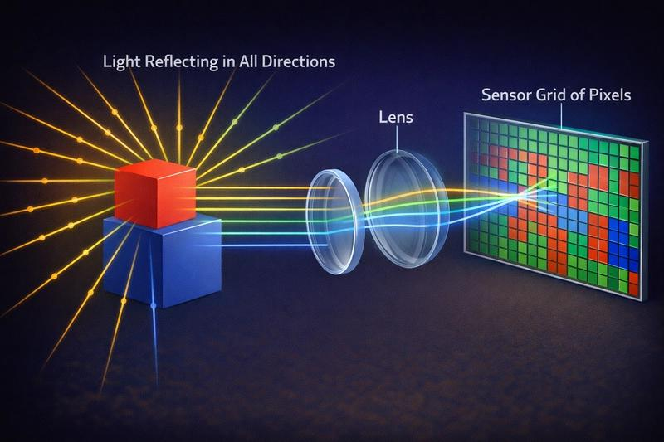

Steps involved in image formation

Illumination: A light source illuminates the fabric surface.

Reflection: Light is reflected from the fabric towards the camera.

Lens focusing: The camera lens focuses the reflected light.

Image sensing: The image sensor receives the focused light.

Signal conversion: The sensor converts light into electrical signals.

Digital conversion: The signals are converted into digital pixel values.

Image processing: The computer processes the digital image to identify defects.

8.3 Components Involved in Image Formation

1. Object

The object is the real-world material being inspected.

In this project, the object is textile fabric moving along a conveyor.

2. Light Source

The light source illuminates the fabric so that the camera can capture its surface details.

Proper lighting is required to identify low-contrast defects such as oil stains.

3. Camera Lens

The lens collects light reflected from the fabric and focuses it onto the image sensor.

The lens should provide sufficient sharpness across the entire inspection area.

4. Image Sensor

The image sensor converts incoming light into electrical signals.

Common sensor technologies include:

CCD (Charge-Coupled Device).

CMOS (Complementary Metal-Oxide-Semiconductor).

5. Digital Image

The final output is a digital image containing pixels that represent the fabric surface.

This image is used for further processing and defect detection.

8.4 Camera Geometry

Camera geometry describes the spatial relationship between the camera, the object and the image plane.

It determines how a three-dimensional real-world object is represented in a two-dimensional image.

In textile inspection, camera geometry is important because the system must measure the actual width and position of fabric defects accurately.

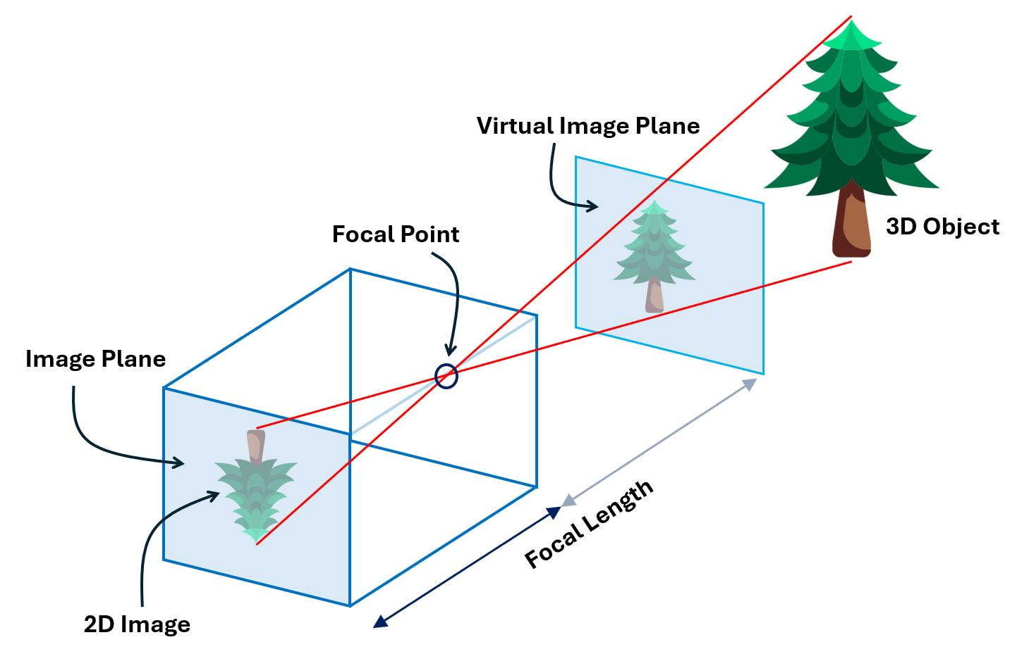

Important elements of camera geometry

Object plane: The physical surface being inspected.

Camera centre: The point through which light rays are projected in the simplified pinhole model.

Image plane: The plane where the camera forms the image.

Focal length: The distance between the camera's optical centre and its image plane in the pinhole-camera model.

Optical axis: The imaginary line passing through the camera centre and perpendicular to the image plane.

These elements determine the scale and position of objects in the captured image.

8.5 Pinhole Camera Model

The pinhole camera model is a simple mathematical model used to explain how a camera forms an image.

It assumes that light travels in straight lines through a very small opening and forms an inverted image on the image plane.

The relationship between object dimensions and image dimensions can be represented using similar triangles.

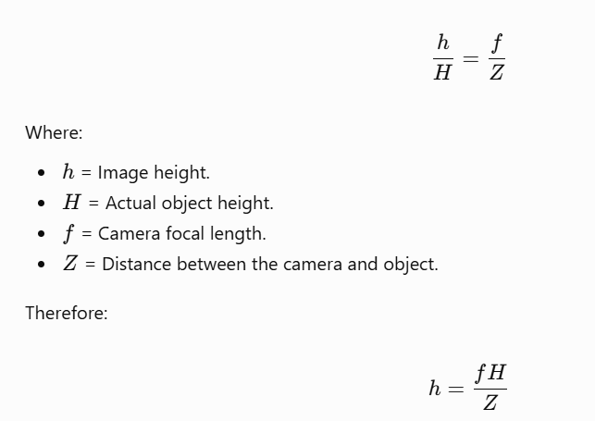

This equation shows that image size depends on the object's actual size, camera focal length and distance from the camera.

Example:

Suppose:

Object height = 100 mm.

Focal length = 25 mm.

Camera distance = 700 mm.

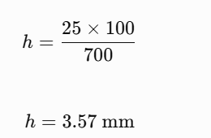

The object would form an image approximately 3.57 mm high on the image plane under the simplified model.

Note: This is an illustrative calculation. Actual camera calibration must account for the lens, sensor size, focus and installation geometry.

8.6 Field of View (FOV)

Field of View refers to the physical area visible to the camera at a particular position.

It determines how much of the fabric can be inspected in a single captured image.

The proposed system has a field of view of:

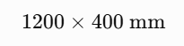

Therefore:

Horizontal field of view = 1,200 mm.

Vertical field of view = 400 mm.

The fabric width is 1,000 mm.

The horizontal margin is:

1200-1000=200

If the fabric is centred:

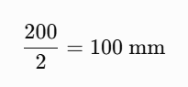

Therefore, approximately 100 mm of additional viewing margin is available on each side.

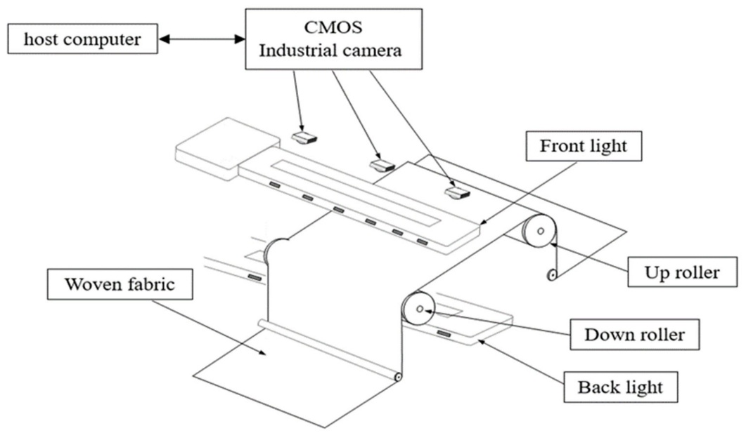

Importance of field of view

Ensures the entire fabric width is visible.

Helps determine camera placement.

Supports accurate image-scale calculations.

Prevents fabric edges from being excluded.

Helps select a suitable camera and lens.

8.7 Camera Calibration

Camera calibration is the process of determining the camera parameters required to relate image coordinates to real-world measurements.

It is important when a Computer Vision system needs to measure the actual dimensions of objects.

In textile inspection, calibration helps measure fabric width and defect size accurately.

Types of camera parameters

1. Intrinsic parameters

These describe the internal characteristics of the camera.

Examples include:

Focal length in pixel units.

Principal point.

Lens distortion coefficients.

2. Extrinsic parameters

These describe the position and orientation of the camera relative to the object or world coordinate system.

Examples include:

Camera position.

Camera rotation.

Camera translation.

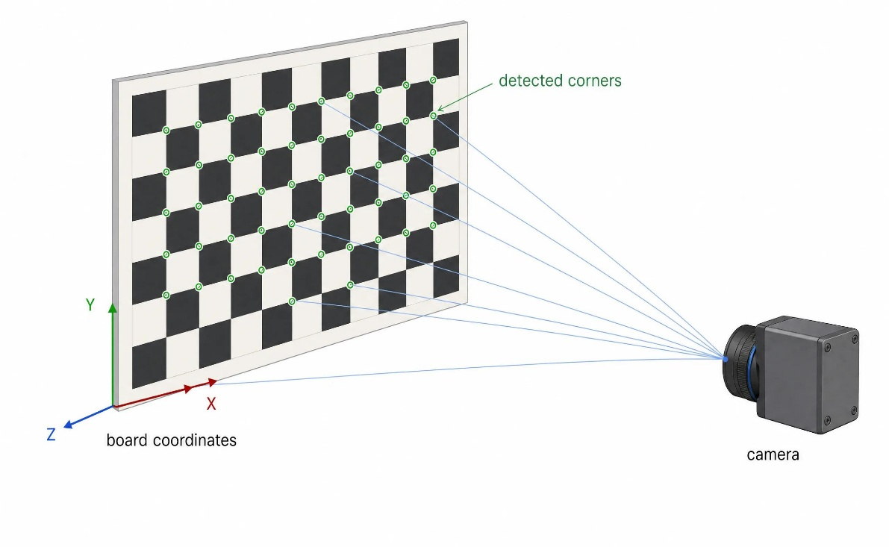

Calibration procedure

Place a known calibration pattern in the inspection area.

Capture several images from different positions or orientations.

Identify the known points in the calibration pattern.

Calculate the camera's intrinsic parameters.

Estimate the camera's position and orientation.

Correct lens distortion.

Verify measurements using a known reference object.

A checkerboard pattern is commonly used for camera calibration.

8.8 Lens Distortion

Lens distortion occurs when the camera lens causes straight lines in the real world to appear curved or displaced in the captured image.

There are two common types.

1. Barrel Distortion

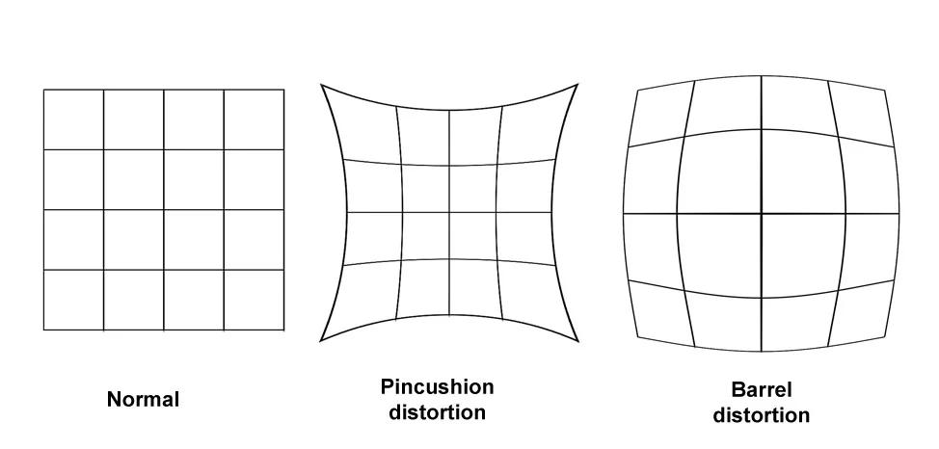

In barrel distortion, straight lines appear to bend outward near the edges of the image.

Effects:

Incorrect measurement near image edges.

Distorted fabric boundaries.

Inaccurate defect positions.

2. Pincushion Distortion

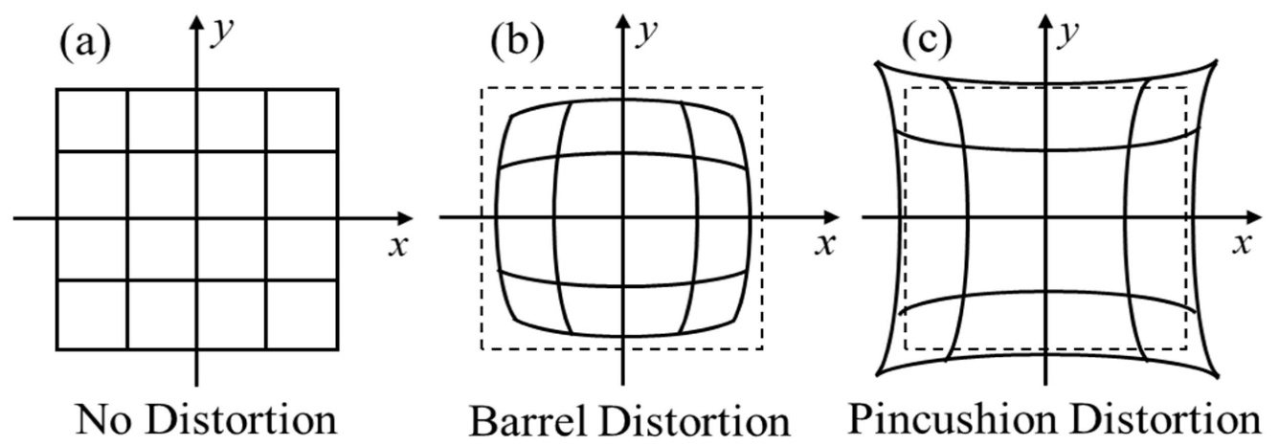In pincushion distortion, straight lines appear to bend inward towards the centre of the image.

Effects:

Incorrect geometric measurements.

Distorted object shapes.

Reduced measurement accuracy.

Methods to reduce lens distortion

Select a suitable industrial lens.

Calibrate the camera.

Apply distortion correction using OpenCV.

Mount the camera securely.

Verify measurements at different positions in the field of view.

8.9 Perspective Distortion

Perspective distortion occurs when objects at different distances from the camera appear to have different sizes.

For example, if a camera is tilted above the fabric, the fabric region closer to the camera may appear larger than the region farther away.

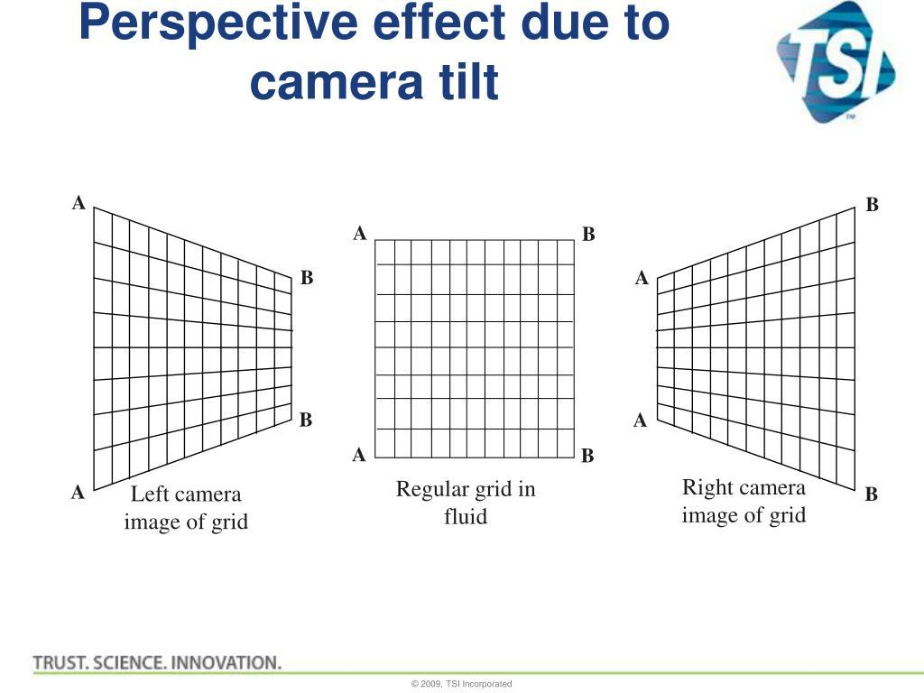

Effects in textile inspection

Fabric width may appear different at different image positions.

Defect dimensions may be measured incorrectly.

Fabric edges may appear slanted.

Defect locations may not correspond accurately to real-world positions.

Methods to reduce perspective distortion

Position the camera perpendicular to the fabric surface.

Use a stable camera mounting arrangement.

Calibrate the camera.

Apply perspective correction when necessary.

8.10 Perspective Transformation and Homography

A perspective transformation is used to correct the appearance of an image when a planar surface is viewed from an angled camera position.

Homography is a mathematical transformation that relates points on one plane to corresponding points in another plane.

It is useful when the fabric surface is approximately planar and the camera view is tilted.

The transformation can be represented as:

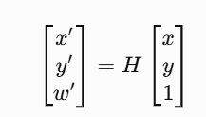

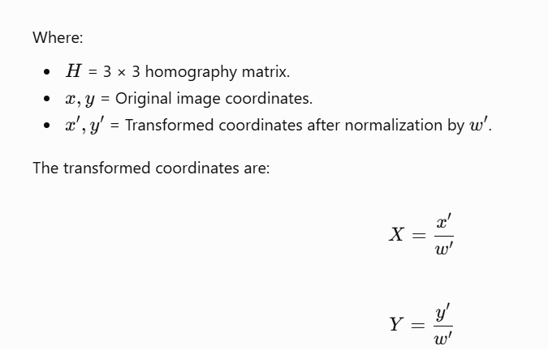

Homography can help convert an angled view of a flat fabric surface into a more rectangular view.

8.11 Importance of Camera Height and Position

The proposed system specifies a camera mounting height of 700 mm.

Camera height affects the field of view and image scale.

When the camera is mounted too close to the fabric:

A smaller area may be visible.

The edges may be excluded.

More than one camera may be required.

When the camera is mounted too far away:

The fabric occupies fewer pixels.

Small defects may become difficult to detect.

A different lens may be required.

Real-Time Quality Inspection through Industry 4.0 Technologies[v1] | Preprints.org

preprints.org

The camera should be positioned so that the full 1,000 mm fabric width fits inside the 1,200 mm field of view.

The final mounting position should be verified using a calibration target and actual fabric samples.

8.12 Measurement Accuracy in Fabric Inspection

Measurement accuracy refers to how closely the measured result matches the actual physical dimension.

The proposed system requires fabric width measurement accuracy of ±2 mm.

For a fabric width of 1,000 mm:

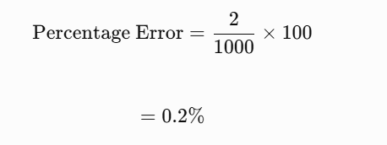

Therefore, the allowed measurement error is approximately 0.2% of the fabric width.

To achieve this accuracy, the system should consider:

Camera calibration.

Lens distortion correction.

Proper camera alignment.

Stable fabric movement.

Consistent lighting.

Accurate pixel-to-millimetre conversion.

A camera's pixel resolution alone does not prove that ±2 mm measurement accuracy can be achieved. The complete system must be calibrated and tested.

8.13 Python Program for Camera Calibration Using OpenCV

The following example demonstrates how camera calibration can be performed using a checkerboard pattern.

import cv2

import numpy as np

import glob

# Checkerboard dimensions

pattern_size = (9, 6)

# Prepare real-world checkerboard coordinates

objp = np.zeros((9 * 6, 3), np.float32)

objp[:, :2] = np.mgrid[

0:9, 0:6

].T.reshape(-1, 2)

# Store 3D and 2D points

object_points = []

image_points = []

# Read checkerboard images

images = glob.glob("calibration_images/*.jpg")

for filename in images:

img = cv2.imread(filename)

if img is None:

continue

gray = cv2.cvtColor(

img,

cv2.COLOR_BGR2GRAY

)

# Find checkerboard corners

found, corners = cv2.findChessboardCorners(

gray,

pattern_size,

None

)

if found:

object_points.append(objp)

image_points.append(corners)

# Perform camera calibration

if len(object_points) > 0:

ret, camera_matrix, distortion, rvecs, tvecs = (

cv2.calibrateCamera(

object_points,

image_points,

gray.shape[::-1],

None,

None

)

)

print("Calibration successful:", ret)

print("Camera Matrix:")

print(camera_matrix)

print("Distortion Coefficients:")

print(distortion)

else:

print("No valid checkerboard images found.")

Explanation of the program

OpenCV is imported for image processing.

NumPy is used to create checkerboard coordinates.

The program searches for calibration images in a folder.

cv2.findChessboardCorners() identifies the checkerboard corners.

The object and image coordinates are stored.

cv2.calibrateCamera() calculates the camera parameters.

The camera matrix and distortion coefficients are displayed.

Important: The example assumes a 9 × 6 internal-corner checkerboard. The checkerboard square dimensions should be measured and entered in real-world units if physical measurements are required. Several clear images from different positions and orientations should be used for reliable calibration.

8.14 Advantages of Proper Image Formation and Camera Geometry

Improves image quality.

Helps maintain accurate object dimensions.

Reduces geometric distortion.

Supports accurate fabric-width measurement.

Helps identify defects at different positions.

Improves the reliability of Computer Vision inspection.

8.15 Limitations

Incorrect camera placement can produce distorted images.

Poor lens quality can affect measurements.

Camera calibration requires suitable reference patterns.

Perspective distortion may affect object dimensions.

Vibration can change camera alignment.

Changes in camera position may require recalibration.

8.16 Conclusion

Image formation and camera geometry are important concepts in developing an accurate Computer Vision system. Image formation explains how light from a real-world object is converted into a digital image, while camera geometry explains the relationship between the object and its image. Camera calibration, field of view, focal length, lens distortion and perspective correction are essential for accurate fabric inspection. In the proposed textile inspection system, correct camera placement and calibration are necessary to inspect the complete 1,000 mm fabric width and achieve the required width measurement accuracy of ±2 mm. Combining proper camera geometry with suitable lighting and image processing can improve the reliability of automated fabric defect detection.

TASK 9 – SYSTEM IMPLEMENTATION AND PERFORMANCE EVALUATION OF THE TEXTILE FABRIC INSPECTION SYSTEM

9.1 Introduction

System implementation is the process of converting a proposed Computer Vision design into a working application. It involves selecting suitable hardware, installing software, developing image-processing algorithms and integrating all components into a complete inspection system.

In textile industries, manual fabric inspection requires workers to continuously observe fabric surfaces and identify defects. This process can be time-consuming and may produce inconsistent results.

An automated textile inspection system uses cameras, lighting equipment, computers and image-processing algorithms to detect defects and support quality control.

The proposed system aims to identify holes, broken threads, oil stains, weaving irregularities and colour variations while inspecting fabric moving on a conveyor.

The system must operate under the following conditions:
Parameter | Requirement
Fabric width | 1,000 mm
Camera field of view | 1,200 × 400 mm
Conveyor speed | 0.6 m/s
Smallest defect | 1.5 mm
Oil-stain contrast | 5–8 grayscale levels
Width measurement accuracy | ±2 mm
Maximum decision time | 0.5 seconds
Camera-to-marker distance | 0.3 m
Lighting | 500–3,000 lux
Computer | 4-core CPU, 16 GB RAM
GPU | Not available
Programming language | Python
Image-processing library | OpenCV
Storage capacity | 2 TB
Network | Gigabit Ethernet
Budget | ₹1,50,000
Image retention | 7 days
Maximum acceptable missed-defect rate | 2%

9.2 Objectives of System Implementation

The main objectives are:

Develop an automated fabric inspection system.

Capture clear images of the moving fabric.

Identify different types of fabric defects.

Measure defect dimensions and locations.

Reduce the requirement for continuous manual inspection.

Provide inspection decisions within the required time.

Store defect images and inspection information.

Maintain consistent inspection performance.

9.3 Proposed System Architecture

The proposed system consists of hardware and software components that work together to inspect fabric.

Fabric Conveyor

Moves fabric through the inspection area

Camera and Lighting System

Captures fabric images

Image Acquisition

Transfers images to the computer

Image Preprocessing

Noise removal, enhancement and colour conversion

Feature Extraction and Defect Detection

Identifies abnormal fabric regions

Decision-Making System

Classifies the fabric as acceptable or defective

Acceptable Fabric

Continue production

Defective Fabric

Alert or activate marker

Database and Inspection Report

Stores defect details and images

9.4 Hardware Requirements

Hardware components are physical devices required to capture, process and store fabric inspection information.

1. Industrial Camera

The industrial camera captures images of the fabric surface.

Requirements:

Suitable resolution for detecting 1.5 mm defects.

Appropriate frame or line rate.

Compatible lens.

Reliable image transfer.

Suitable exposure control.

A line-scan camera is a suitable option for continuous fabric inspection. A global-shutter area-scan camera may also be considered for a prototype.

2. Industrial Lens

The lens focuses light onto the camera sensor.

It should provide:

Suitable field of view.

Adequate image sharpness.

Minimum distortion.

Proper focus across the fabric width.

3. Lighting System

Lighting improves the visibility of defects.

LED lighting can provide controlled illumination across the inspection area. Backlighting may be used for detecting holes, while front or diffuse lighting can help identify stains and surface irregularities.

4. Computer System

The computer processes the captured images and executes the defect-detection program.

The specified configuration includes:

4-core CPU.

16 GB RAM.

No dedicated GPU.

Therefore, the software should be optimized for CPU-based processing.

5. Conveyor and Encoder

The conveyor transports fabric through the inspection area. An encoder can measure conveyor movement and help synchronize image acquisition with fabric position.

6. Marker or Alert System

A marker or alert mechanism identifies defective fabric regions. The system should associate the detected defect with the correct physical location on the moving fabric.

7. Storage System

A 2 TB storage device stores:

Captured images.

Defect images.

Inspection results.

Reports.

System logs.

9.5 Software Requirements

The proposed system can be developed using Python and OpenCV.
Software or library | Purpose
Python | Main programming language
OpenCV | Image processing
NumPy | Numerical calculations
Matplotlib | Image visualization
Pandas | Inspection data management
SQLite | Local database storage
PyCharm or VS Code | Development environment

Role of Python

Python is used to develop the main inspection program. It connects the image-processing stages and manages the inspection workflow.

Role of OpenCV

OpenCV provides functions for:

Reading images.

Converting colour spaces.

Applying filters.

Detecting edges.

Thresholding.

Identifying connected components.

Drawing defect boundaries.

Role of NumPy

NumPy is used for mathematical operations on image arrays and pixel values.

9.6 Image Processing Workflow

The proposed system follows a sequence of image-processing operations.

Step 1: Image Acquisition

The camera captures the fabric image under controlled lighting conditions.

Step 2: Image Preprocessing

Preprocessing improves image quality before defect detection.

Common operations include:

Grayscale conversion.

Noise removal.

Contrast enhancement.

Image resizing, if appropriate.

Colour-space conversion.

Step 3: Defect Segmentation

Segmentation separates possible defect regions from normal fabric.

Methods include:

Thresholding.

Edge detection.

Colour-based segmentation.

Texture analysis.

Step 4: Feature Extraction

The system extracts important information from the segmented regions.

Examples include:

Area.

Width and height.

Shape.

Perimeter.

Mean intensity.

Colour differences.

Texture features.

Step 5: Defect Classification

The detected regions are classified into possible categories such as:

Hole.

Broken thread.

Oil stain.

Colour variation.

Weaving irregularity.

Step 6: Decision Making

The system evaluates the detected defects according to predefined quality requirements.

It can produce:

Acceptable.

Defective.

Requires manual review.

Step 7: Report Generation

The system stores defect details and generates an inspection report.

9.7 Proposed Defect Detection Methods
Defect type | Possible detection technique
Holes | Thresholding and connected components
Broken threads | Edge and texture analysis
Oil stains | Grayscale contrast and colour analysis
Colour variations | RGB or HSV analysis
Weaving irregularities | Texture analysis and pattern comparison

These are proposed techniques. The best method must be selected and validated using representative fabric images.

9.8 Decision-Making Logic

The decision-making system evaluates whether the inspected fabric satisfies the predefined quality requirements.

A simple decision process can be:

The actual acceptance rules must be defined by the textile quality-control requirements.

9.9 Performance Evaluation

Performance evaluation measures how effectively the system performs its intended functions.

Important performance measures include:

1. Detection Accuracy

Accuracy measures the proportion of correct predictions among all predictions.

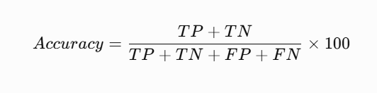

Where:

TP = True Positives.

TN = True Negatives.

FP = False Positives.

FN = False Negatives.

2. Precision

Precision measures how many predicted defects are actually defects.

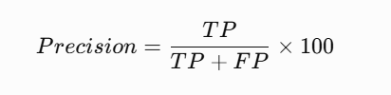

3. Recall

Recall measures how many actual defects are successfully detected.

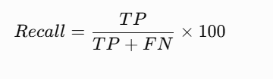

4. Missed-Defect Rate

The missed-defect rate measures the proportion of actual defects that the system fails to detect.

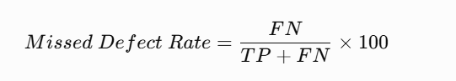

The proposed system permits a maximum missed-defect rate of 2%.

Therefore, the required recall is:

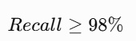

This requirement must be demonstrated using a properly labelled test dataset.

5. Processing Time

Processing time is the duration required to capture, process and classify an image.

The proposed system has a maximum decision-time requirement of 0.5 seconds.

Each processing stage should be measured to determine whether the total time remains within the required limit.

9.10 Decision Timing Calculation

The camera-to-marker distance is 0.3 m, and the conveyor speed is 0.6 m/s.

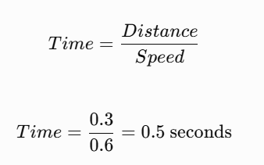

Therefore, the available travel time between the camera and marker is 0.5 seconds.

The system must process the image, make a decision and send the marker command within the available time, allowing for communication and actuator delays.

A suitable safety margin should also be maintained.

9.11 Storage Requirement and Data Management

The proposed system has 2 TB of storage and must retain images for seven days.

High-resolution images can consume significant storage space.

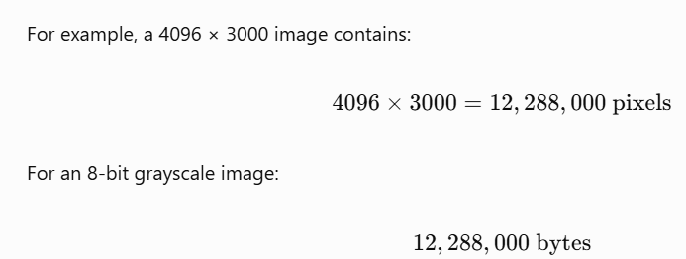

This is approximately 11.72 MiB per image.

For an RGB image with three 8-bit channels, the size is approximately 35.16 MiB.

Therefore, storing every high-resolution frame continuously may exceed the available storage.

Possible solutions:

Store defect images instead of every normal image.

Use suitable image compression.

Store inspection summaries separately.

Apply a seven-day automatic retention policy.

Maintain backup copies of important defect records.

9.12 Illustrative Budget Estimation

The total project budget is ₹1,50,000.

The following is an illustrative allocation, not a verified supplier quotation.
Component | Estimated cost
Camera and lens | ₹62,000
Lighting system | ₹25,000
Protective enclosure | ₹12,000
Encoder and marker interface | ₹15,000
Network and cables | ₹8,000
Storage and backup | ₹18,000
Integration and calibration | ₹10,000
Total | ₹1,50,000

The final budget must be confirmed using actual equipment quotations and installation requirements.

9.13 Testing and Validation

The system should be tested using different types of fabric samples.
Test case | Purpose
Normal fabric | Check false-positive detection
Fabric with holes | Verify hole detection
Fabric with oil stains | Test low-contrast defect detection
Fabric with broken threads | Verify thread-defect detection
Fabric with colour variation | Check colour analysis
Fabric moving at 0.6 m/s | Test performance under movement
Fabric-width measurement | Verify ±2 mm requirement
Repeated inspection | Check system consistency

The testing process should compare system predictions with manually verified defect labels.

No actual detection accuracy or processing-time result is assumed in this report because experimental results have not been supplied.

9.14 Advantages of the Proposed System

Reduces dependence on continuous manual inspection.

Supports consistent defect identification.

Provides digital records of fabric defects.

Helps identify defect locations.

Supports quality-control decisions.

Can reduce the time needed for manual checking.

Provides a foundation for future industrial automation.

9.15 Limitations of the Proposed System

Detection quality depends on camera and lighting conditions.

Low-contrast defects can be difficult to identify.

CPU-only processing may limit throughput.

Large images require additional storage and processing.

Closely located defects may be incorrectly grouped.

The system requires calibration and regular maintenance.

Actual accuracy must be established through testing.

9.16 Conclusion

System implementation combines cameras, lighting, computer hardware, software and image-processing algorithms to develop an automated fabric inspection solution. The proposed system uses Python, OpenCV and NumPy to process captured fabric images and identify possible defects. Performance is evaluated using accuracy, precision, recall, missed-defect rate and processing time. The system must satisfy the required maximum missed-defect rate of 2%, decision time of 0.5 seconds and fabric-width measurement accuracy of ±2 mm. These targets require practical testing and validation. A properly implemented system can support industrial quality control and reduce the dependence on manual fabric inspection.

TASK 10 – ADAPTING THE TEXTILE FABRIC INSPECTION SYSTEM TO CHANGED PRODUCTION REQUIREMENTS

10.1 Introduction

Industrial production requirements may change over time because of improvements in manufacturing technology, increased production demand and stricter quality standards.

A Computer Vision system designed for one production environment may not perform effectively when the operating conditions change.

Therefore, the system must be evaluated and modified whenever production speed, defect size, lighting conditions, inspection time or production volume changes.

In this task, the existing textile fabric inspection system is considered under a new set of production requirements. The system must be adapted to detect smaller defects, inspect fabric at a higher speed and identify stains that are visible under ultraviolet light.

The existing system uses a 4-core CPU, 16 GB RAM and no dedicated GPU. The original budget is ₹1,50,000.

The changed requirements are considered below.

10.2 Changed Production Requirements

The following changes are considered for the redesigned system:
Parameter | Original requirement | Changed requirement
Smallest defect size | 1.5 mm | 0.4 mm
Conveyor speed | 0.6 m/s | 1.2 m/s
Stain detection | Visible-light inspection | UV-visible stains must also be detected
Production volume | Original production rate | Double the production volume
Maximum decision time | 0.5 seconds | 0.3 seconds
Computer | 4-core CPU, 16 GB RAM | Same computer
GPU | Not available | Not available
Budget | ₹1,50,000 | Same budget

These changes create additional requirements for the camera, lighting, processing system and inspection workflow.

10.3 Challenges Created by the New Requirements

The changed production conditions create five major challenges.

1. Detecting Smaller Defects

The smallest defect size has decreased from 1.5 mm to 0.4 mm.

This means the system must identify defects that are much smaller than before.

The existing camera resolution may not provide enough pixels to represent these defects clearly.

2. Increased Conveyor Speed

The conveyor speed increases from 0.6 m/s to 1.2 m/s.

The fabric now moves twice as fast.

This increases the possibility of motion blur and places greater demands on image acquisition and processing.

3. UV-Visible Stain Detection

The system must now detect stains that may not be visible under ordinary white lighting.

This requires additional illumination and potentially a camera sensor suitable for the selected UV wavelength.

4. Double Production Volume

The production volume doubles.

The inspection system must process more fabric within the same operating period.

This increases the demand for image acquisition, processing speed and storage.

5. Reduced Decision Time

The available decision time decreases from 0.5 seconds to 0.3 seconds.

The complete system must therefore operate more efficiently.

10.4 Adaptation of Camera Resolution

The smaller defect size of 0.4 mm requires a higher spatial resolution.

The original horizontal field of view is 1,200 mm.

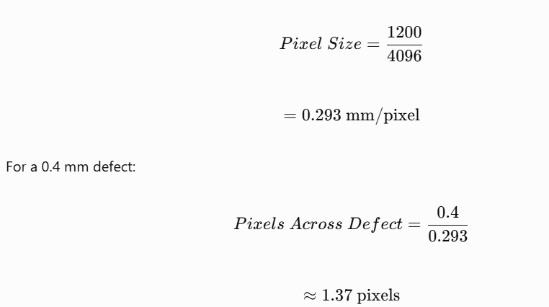

A defect represented by approximately 1.37 pixels may be difficult to detect and measure reliably.

Improved resolution calculation

Suppose the system requires at least four pixels across a 0.4 mm defect as an initial design target.

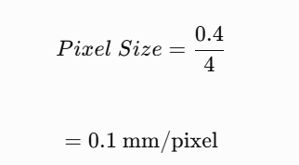

The required horizontal camera resolution is:

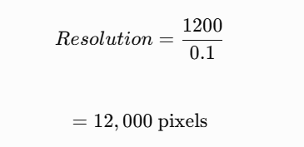

Therefore, approximately 12,000 horizontal pixels would be required to represent a 0.4 mm defect using four pixels across its width.

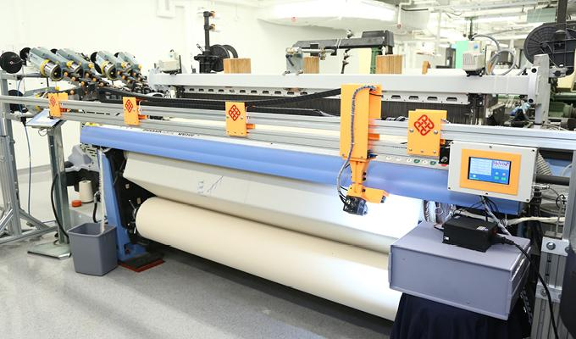

Recommendation: A higher-resolution line-scan camera should be considered for continuous inspection of the moving fabric. However, the final resolution must be selected based on the required detection reliability, lens quality and available processing capacity.

10.5 Adaptation of Conveyor Speed and Exposure Time

The conveyor speed increases from 0.6 m/s to 1.2 m/s.

As the fabric moves faster, the camera must use a shorter exposure time to prevent motion blur.

The motion blur is calculated using:

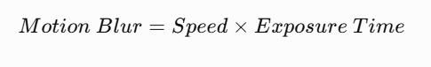

Example 1: Exposure time of 1/2000 second

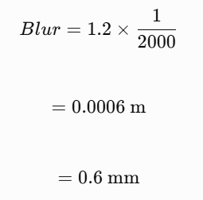

This is greater than the smallest defect size of 0.4 mm.

Example 2: Exposure time of 1/12000 second

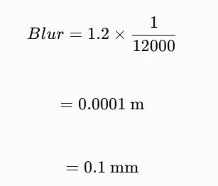

This reduces the approximate motion blur to 0.1 mm.

Recommendation:

Use a camera that supports very short exposure times.

Increase lighting intensity where appropriate.

Consider global-shutter imaging for area-scan cameras.

Synchronize image capture with conveyor movement.

Use an encoder to track fabric position.

The exposure time of 1/12000 second is an illustrative design target. The actual setting must be tested to ensure sufficient image brightness and defect visibility.

10.6 Adaptation for UV-Visible Stain Detection

Some stains may not be clearly visible under ordinary white lighting.

Ultraviolet illumination can help reveal certain substances through their fluorescence or other wavelength-dependent responses.

Proposed UV inspection process

Install a suitable UV illumination source.

Pass fabric through a controlled inspection area.

Capture images using a camera compatible with the required wavelength.

Apply suitable optical filtering where necessary.

Analyse the captured images.

Identify unusual fluorescent regions.

Classify the regions for further inspection.

Hardware requirements

Suitable UV light source.

Camera sensor with adequate sensitivity at the selected wavelength.

Compatible lens and optical filter.

Protective enclosure.

Controlled illumination conditions.

Advantages

Helps reveal certain otherwise difficult-to-see stains.

Provides additional information beyond visible-light imaging.

Can improve the identification of specific fluorescent contaminants.

Limitations

Not all stains fluoresce under UV light.

Some fabric dyes and optical brighteners may also fluoresce.

Different materials may produce similar fluorescence.

UV exposure requires suitable safety precautions.

The camera and filters must be selected for the actual wavelength.

Recommendation: Use visible-light and UV inspection as complementary methods. The system should compare their results rather than assuming that every stain can be detected using UV illumination.

10.7 Adaptation to Double Production Volume

The production volume doubles under the changed conditions.

This means the inspection system must handle more fabric within the same production period.

The increased production rate creates additional demands on:

Camera acquisition rate.

Image-transfer speed.

CPU processing.

Memory usage.

Storage capacity.

Inspection reporting.

Proposed solutions

1. Use a line-scan camera

A line-scan camera captures successive lines as the fabric moves. It is suitable for continuous inspection and can be synchronized with the conveyor encoder.

2. Optimize image processing

Unnecessary processing operations should be removed. Images should be processed efficiently without losing the details needed for defect detection.

3. Use region-of-interest processing

The system can focus on relevant regions rather than applying expensive operations to every pixel unnecessarily.

4. Process images in stages

Image acquisition, preprocessing and defect detection can be organized efficiently to reduce delays.

5. Store only necessary images

Defect images and important inspection records should be retained, while normal images may be managed using a defined retention policy.

10.8 Adaptation to Reduced Decision Time

The maximum decision time is reduced from 0.5 seconds to 0.3 seconds.

The original camera-to-marker distance is 0.3 m.

At the new conveyor speed of 1.2 m/s:

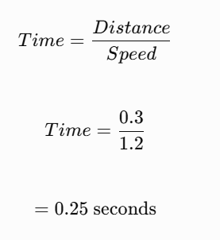

Timing constraint

The physical travel time from the camera to the marker is now only 0.25 seconds.

This means the system cannot rely on the previous 0.5-second timing assumption.

The required 0.3-second decision time must also account for the time taken by image capture, processing, communication and marker activation.

Possible improvements

Use a faster image-acquisition system.

Reduce unnecessary image-processing operations.

Optimize OpenCV operations.

Process only relevant image regions where possible.

Use efficient data-transfer methods.

Send the marker command immediately after a valid decision.

Measure the complete end-to-end delay.

A decision made after the fabric has reached the marker cannot be applied to the correct physical location. Therefore, timing must be validated under actual conveyor conditions.

10.9 Adapting the Existing CPU-Based System

The existing computer has:

4-core CPU.

16 GB RAM.

No dedicated GPU.

The changed requirements involve higher image resolution, faster fabric movement and double production volume.

This increases the processing workload.

Proposed software improvements

1. Efficient image processing

Use optimized OpenCV functions rather than unnecessary pixel-by-pixel Python loops.

2. Image resizing only when safe

Avoid resizing images below the resolution required for detecting 0.4 mm defects.

3. Region-of-interest analysis

Analyse relevant sections of the fabric while retaining enough information to identify small defects.

4. Memory management

Release unnecessary image arrays and reuse buffers where practical.

5. Parallel processing

Use suitable CPU-based parallel processing to improve throughput, while checking that it does not create additional delays.

6. Lightweight algorithms

Prefer computationally efficient methods that can run within the available hardware capacity.

Important limitation

The same 4-core CPU may not be able to process the increased resolution and production volume within the required decision time.

Therefore, the system must be benchmarked before confirming that the existing computer is sufficient.

10.10 Revised System Architecture

The revised system should combine visible-light inspection, UV inspection, high-resolution image acquisition and efficient CPU-based processing.

High-Speed Fabric Conveyor

1.2 m/s fabric movement

Visible-Light Camera

Normal defects and colour differences

UV Inspection

Certain fluorescent stains

High-Resolution Image Acquisition

Encoder synchronization and short exposure

Optimized CPU-Based Image Processing

Preprocessing, segmentation and feature extraction

Defect Classification and Decision

Acceptable, defective or manual review

Accept

Alert / Mark

Inspection Records and Storage

10.11 Revised Budget Considerations

The revised system must operate within the same budget of ₹1,50,000.

This creates a challenge because the new requirements may require more expensive camera and lighting equipment.

The following table provides an illustrative allocation for planning purposes.
Component | Proposed allocation
High-resolution camera and lens | ₹65,000
Visible and UV lighting | ₹25,000
Protective enclosure | ₹10,000
Encoder and marker interface | ₹15,000
Network and cables | ₹7,000
Storage and backup | ₹15,000
Integration and calibration | ₹13,000
Total | ₹1,50,000

Important: These are estimated budget allocations, not verified market prices. A high-resolution camera with suitable UV sensitivity and optics may exceed the allocation. The actual design may therefore require trade-offs, reuse of existing components or a revised budget.

10.12 Comparison Between Original and Revised Systems
Feature | Original system | Revised system
Smallest defect | 1.5 mm | 0.4 mm
Conveyor speed | 0.6 m/s | 1.2 m/s
Lighting | Visible light | Visible and UV
Production volume | Original | Double
Decision time | 0.5 seconds | 0.3 seconds
Camera resolution | Original design | Higher resolution required
Image acquisition | Standard inspection | High-speed synchronized acquisition
Processing | Basic CPU pipeline | Optimized CPU pipeline
Computer | 4-core CPU, 16 GB RAM | Same computer
Budget | ₹1,50,000 | ₹1,50,000

10.13 Testing and Validation of the Revised System

After modifying the system, practical testing is necessary to verify that it meets the new production requirements.
Test | Purpose
0.4 mm defect test | Verify detection of smaller defects
High-speed movement test | Check image quality at 1.2 m/s
Motion-blur test | Verify short exposure performance
UV stain test | Identify suitable fluorescent stains
Double-volume test | Check processing throughput
Decision-time test | Verify the 0.3-second requirement
CPU utilization test | Measure processing load
Storage test | Check seven-day retention
Marker synchronization test | Verify correct defect marking

Performance measures

The revised system should be evaluated using:

Detection recall.

Missed-defect rate.

False-positive rate.

Processing time.

End-to-end decision latency.

Defect measurement error.

Image quality.

CPU and memory utilization.

The results should be compared with the original system to determine whether the modifications improve performance.

10.14 Advantages of the Revised System

Supports detection of smaller defects.

Provides improved image detail.

Supports higher-speed fabric inspection.

Can identify certain stains using UV illumination.

Supports increased production throughput.

Uses optimized image-processing operations.

Improves the flexibility of the inspection system.

Provides a foundation for future industrial improvements.

10.15 Limitations of the Revised System

High-resolution cameras may increase system cost.

UV illumination requires additional hardware and safety measures.

The existing CPU may not meet the increased processing demand.

Higher-resolution images require additional storage.

Increased conveyor speed reduces the time available for decision-making.

Not all stains are detectable using UV illumination.

The fixed budget may limit the selection of suitable hardware.

The revised design requires extensive testing before industrial deployment.

10.16 Conclusion

The revised textile inspection system must be adapted to handle smaller defects, higher conveyor speed, UV-visible stains, double production volume and reduced decision time. A higher-resolution camera, suitable UV illumination, short exposure time and encoder-based synchronization are important improvements. The existing 4-core CPU and 16 GB RAM must be evaluated carefully because the increased image-processing workload may exceed its capabilities. The budget of ₹1,50,000 also creates limitations in selecting advanced hardware. Therefore, the revised system should use optimized image-processing methods, efficient storage management and practical performance testing. These changes can help develop a more flexible and reliable textile fabric inspection system, provided the required performance is demonstrated experimentally.

Mark Distribution
Task | Topic | Marks
1 | Overview and Features of Computer Vision | 4
2 | Levels of Computer Vision | 5
3 | Image Representation | 4
4 | Connectivity Analysis | 4
5 | Image Acquisition | 5
6 | Sampling Analysis | 5
7 | Quantization Analysis | 4
8 | Image Formation | 5
9 | Implementation and  Performance Evaluation | 6
10 | Front-End Adaptation Challenge | 8
 | TOTAL | 50

Submission Requirements
  - Submit a neatly formatted assignment report with task-wise headings.
  - Include hand-drawn or computer-generated diagrams wherever required.
  - Show all numerical calculations with formulae, substitution and final units.
  - Include comparison tables and evidence supporting the selected techniques.
  - For implementation tasks, attach source code, sample input images and output screenshots.
  - Mention references, tools and software libraries used.

